Test Request Site Design Specifications

Table of Contents

Project Overview 2

Test Request Workflow Key 3

Main Process 4

Optional Processes 4

The Test Request Site 5

Form Creation 10

Design of Form Views 12

InfoPath Form Load Rules 25

Building the Workflow 32

Creating the Site Content 49

Tester Request Library Setup 50

The Site Homepage 58

Building the Test Machines Schedules Form and Library 76

The Calendar Pages 97

The Test Machines Master Schedule Page 104

## Project Overview

This site is built using InfoPath Web Forms. The forms are in the Test Machine schedule system and the Test Request library. The form in the test request library has multiple views.

The programming for the Test Request workflow is activated using the Form Load parameters to set the security and view on the form when it opens. The form views have submit buttons that set hidden field values for the Form Status and the Next Approver used in the workflow process.

A SharePoint workflow is used to send email to the approver/tester as each new request is created with a link to the appropriate form view to fill out. Finally when the tests are completed they are stored in a read only format and the original requestor is sent a link to the form. There are points in the approval process, both for new submissions and completed tests, where a reviewer can request a resubmission with changes before approving the form. Emails used for tracking progress are sent to the approver.

The site front page shows the current viewer’s list for tests In Progress, Final review, In Progress Review and Approved. Below is displayed a list for their Completed tests. To the side is a calendar that shows the schedules of the tests In Progress.

SharePoint site security using groups secure the available links and views and limit the actions of the users. Depending on the group security, users may be unable to delete but can create or edit.

The Test Machine schedule system allows the scheduling of the tests and tracks each entry to an existing project so that the data from the two can be linked in an excel spreadsheet (Both lists can be exported to excel). The tracking includes Test Machine type, test type, cells used and start and stop dates and are also loaded into a calendar view.

## 

## Test Request Workflow Key

Main Process

1

Test Request

Optional

A

Resubmit Request

2

Approval

**G**

**Test Machine Scheduler**

(Linked by Project)

Used through this process sequence

B

Test Engineer Estimate Schedule

3

Test Engineer Start

6

Completed

C

Test Engineer Resubmit

5

Test Review

4

Test Engineer In Progress

D

Cancelled

F

Removed from Calendar

E

Edit Comments In Completed

(Approver Only)

## **Main Process**

1. The workflow starts with a Test Request being submitted.
2. An E-Mail is sent to the Approver with a link to the Test Request form.
3. The Approver approves the request and the assigned test engineer will receive an email that requests the test to be started with a link to the Start Form.
4. The Test Engineer submits the start date. The requester and the approver are notified by email the testing has started with a link to the Test Form (read only for the requester).
5. The Test Engineer works on the test with the status being In Progress. When done he submits it. An email is sent to the Approver requesting a Test Review.
6. The Approver can then approve the tests for a completed status.

## **Optional Processes**

1. After the initial request, the Approver can ask for a revision and a resubmit from the requester.
2. The Approver can also ask the Test Engineer to provide an estimated test completion time.
3. During the testing process the Approver and Test Engineer can update or change the test schedule with two way communication via the form comments. The Test Engineer can also make the Approver aware of any problems with the test.
4. The Approver can also cancel the test if requested.
5. After completion, the Approver can still edit his final comments.
6. Finally the test is removed from the current Tests In Progress calendar.
7. At any time during the Approved to In Processes Status, the Test Machine scheduler can be used to modify the Test Machines used and the testing dates. These changes can be sent to the Test Engineer to notify them of the scheduling change. These changes are also tracked in the Test Machine scheduler site.

## **The Test Request Site**

### SharePoint Test Request Site Creation

For security reasons and the overall safety of the SharePoint environment, creating a Test Request sub-site under the Test and Validation site will offer the most freedom for self-administration without allowing the end user(s) enough access to impact anything outside their site.

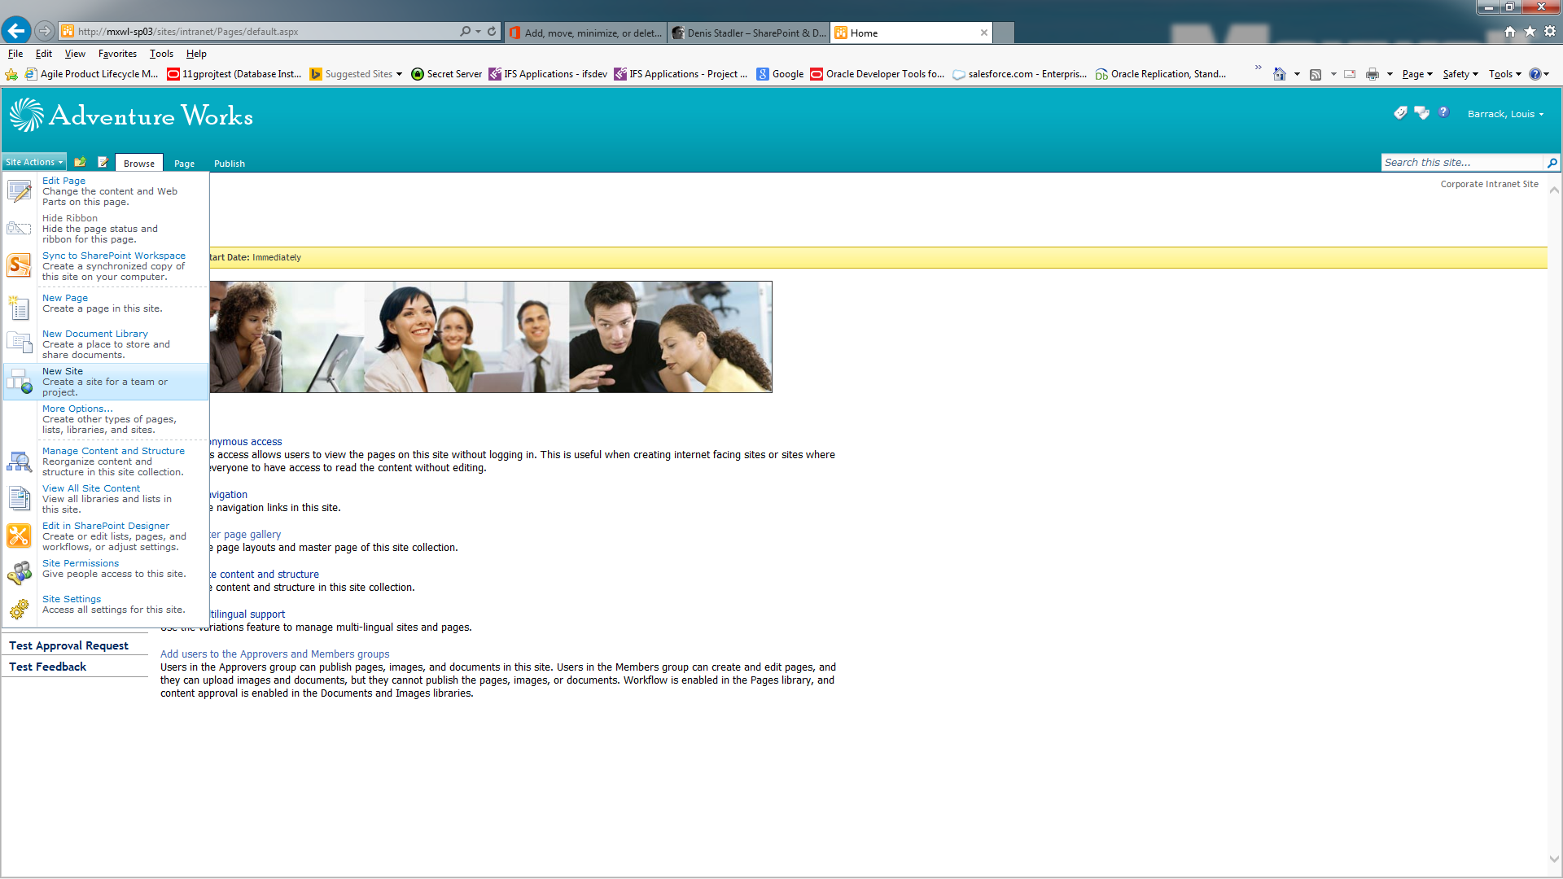

With the proper SharePoint security level, go to Site Actions – New Site

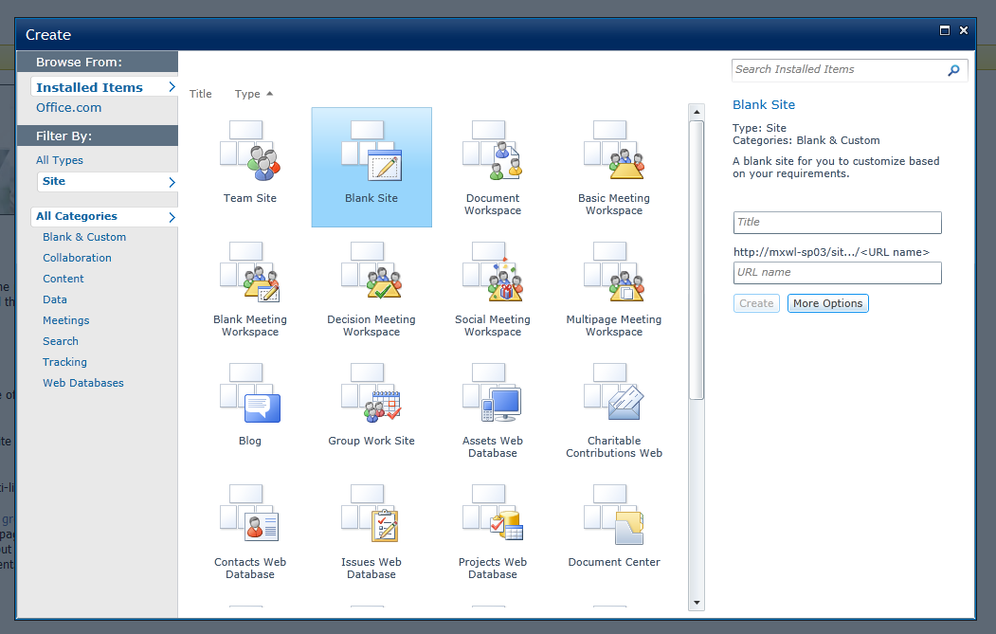

Select Blank Site and name it accordingly (i.e. Test Approval Requests). Then click create.

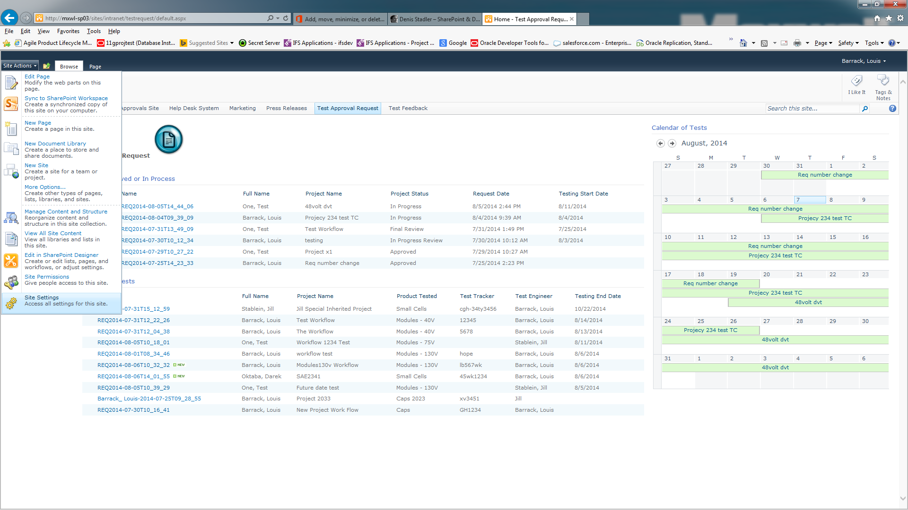 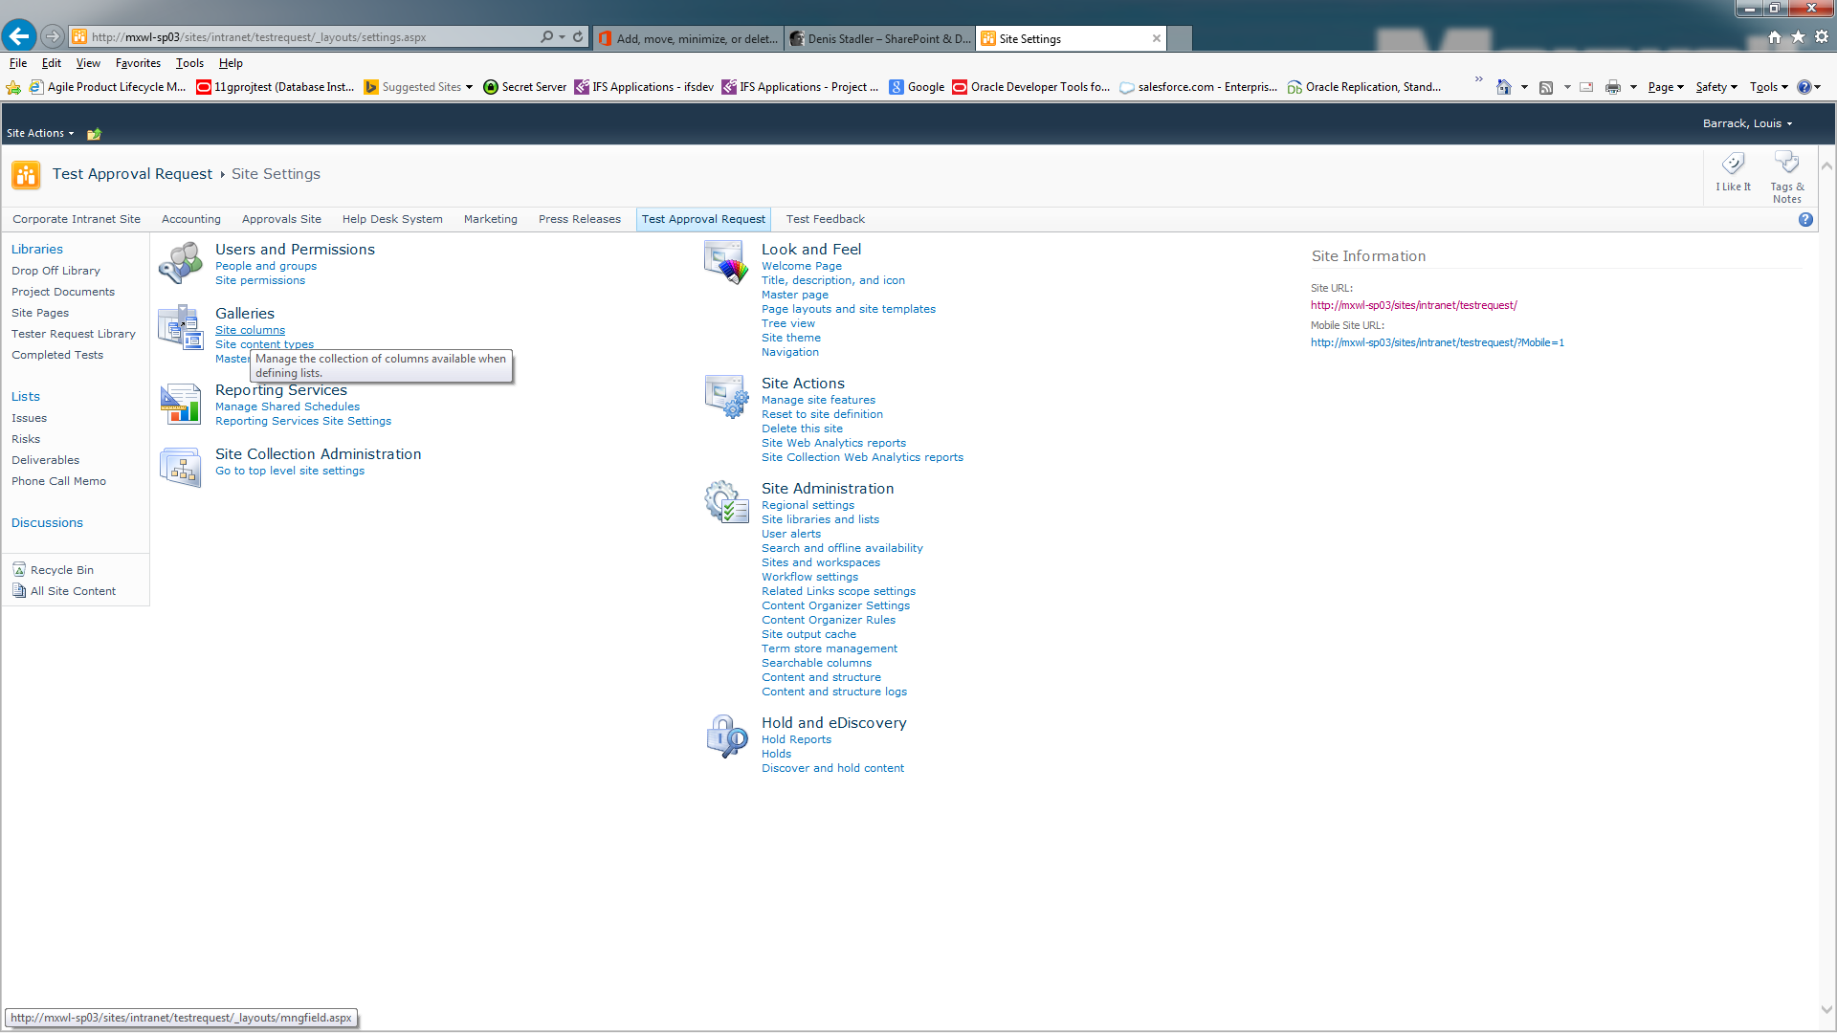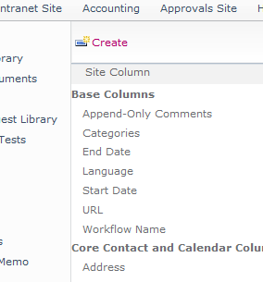

Go to Site Actions – Site Settings

Under Galleries select Site Columns

In the new screen click Create at the top

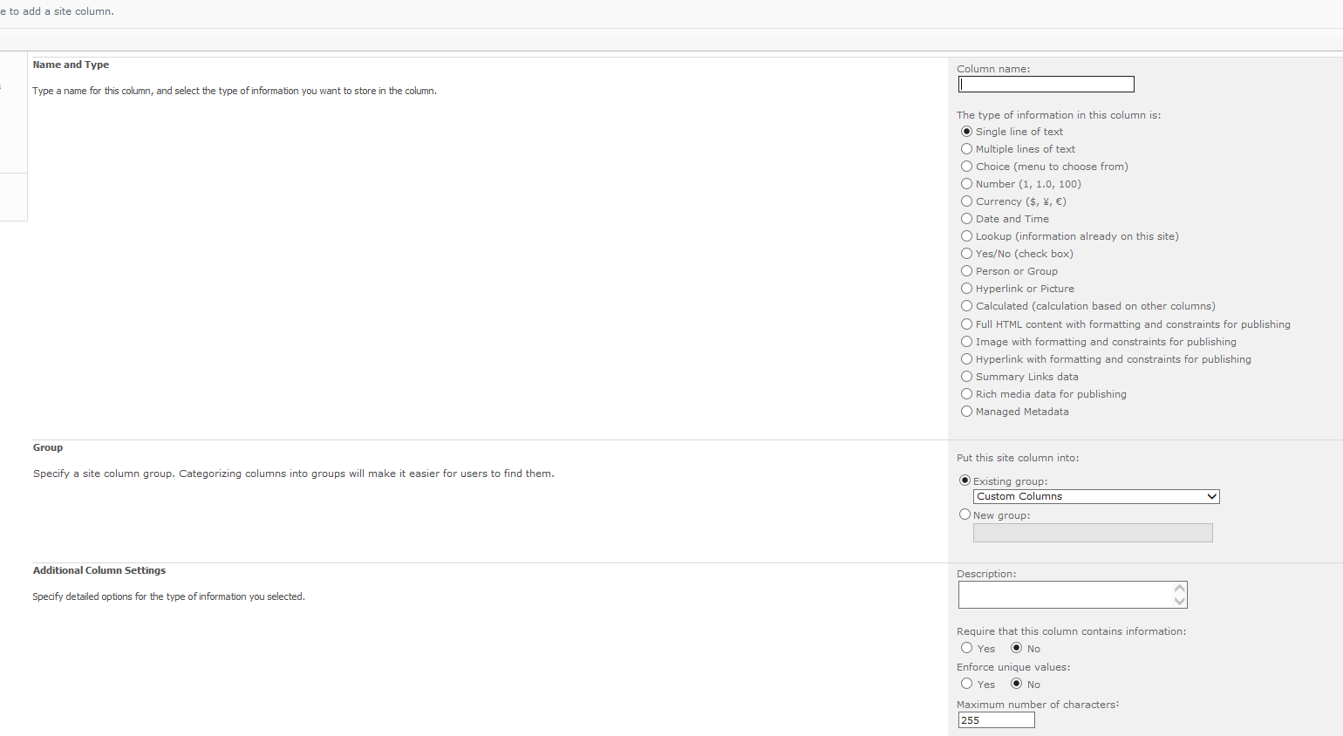

Name the column Form Status and then select **Single line of text**. Scroll down to **Put this site column into**. In the **New group** field type Company Workflow. Leave the rest at default and hit **OK**. Do the same for a column named Next Approver, Master Approver, Eproj Name and Test Schedule except select **Existing group** and add them to **Company Workflow**.

When done it should look like this at the bottom of the list:

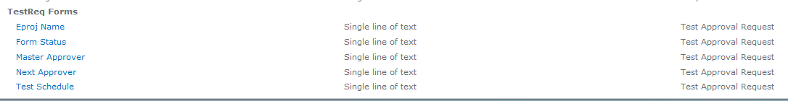

The following is for visual reference only, the document will detail the settings/creation details later.

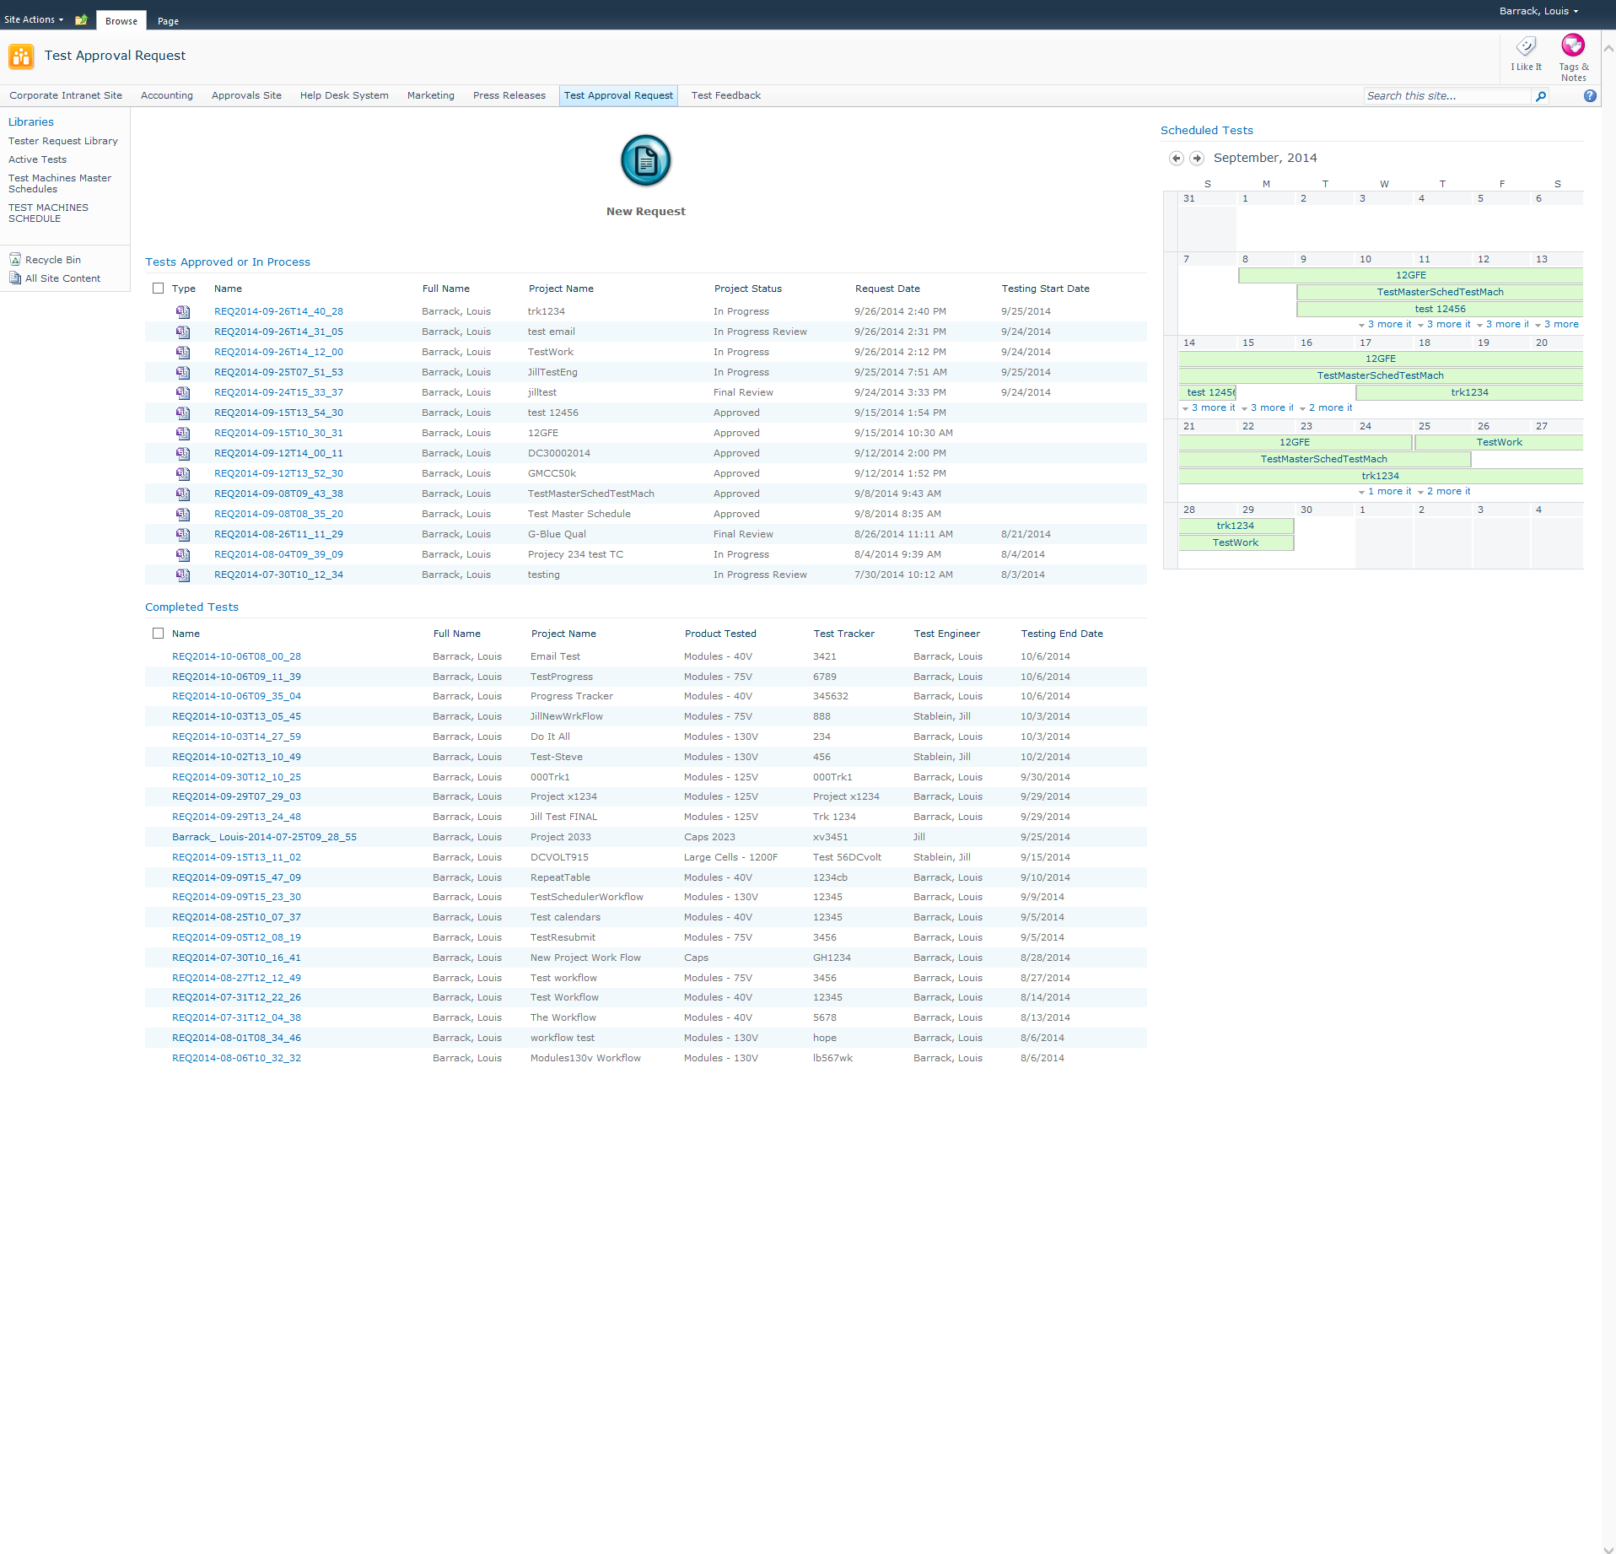

Site Front Page when completed

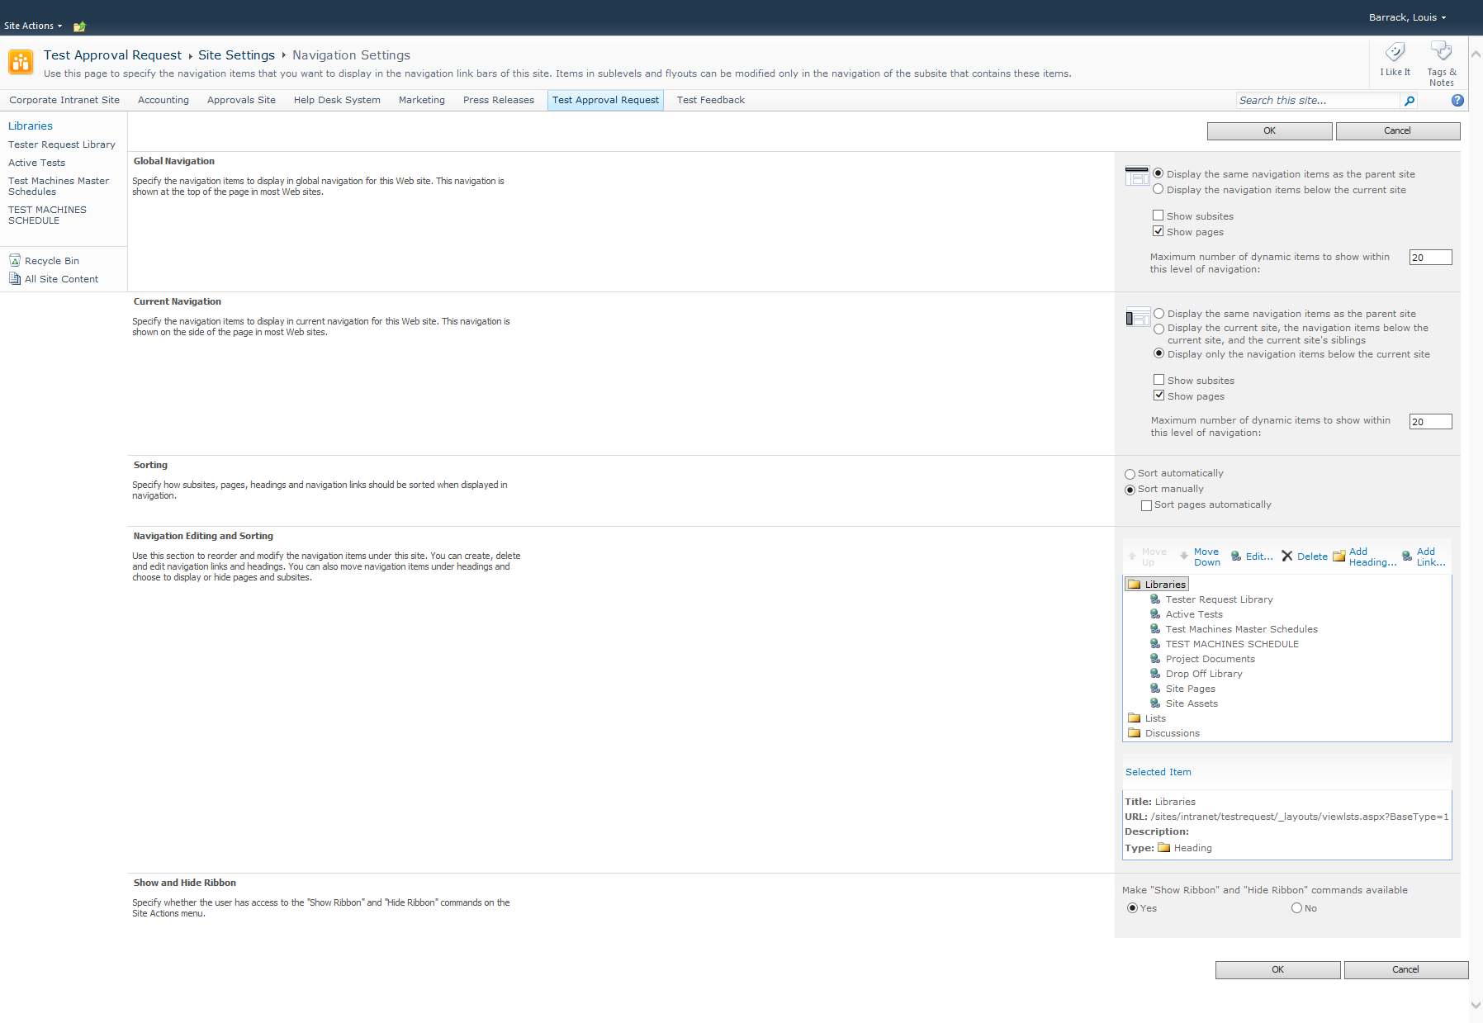

Site navigation settings

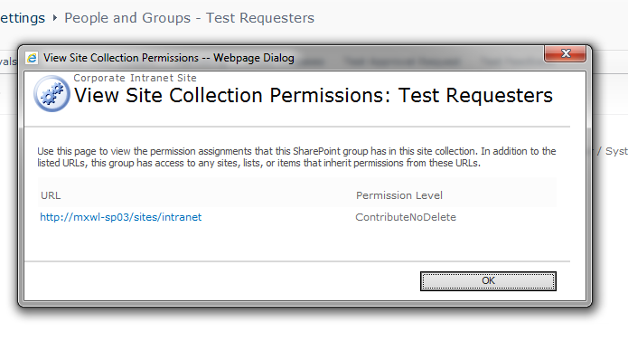

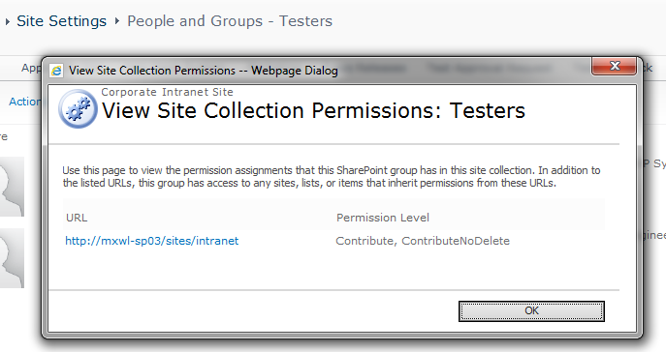

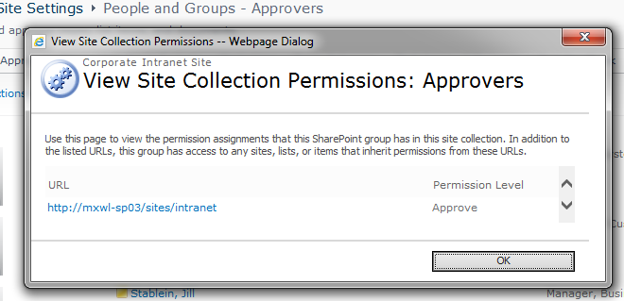

Site security groups

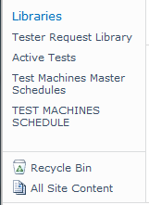

Site Links

THE INFOPATH FORM

This form is already created and saved. It can be uploaded into a new site. The following gives a general background on its creation.

The InfoPath form has ten views:

New(default), Approvals, EmachCheck, Resubmit, Testers, Test Start, Final Review, Testers Read Only, Edit Closed, and Test Machines Schedules.

Each view has Submit buttons with unique rules and fields designated as required before submission. Also some fields are pre-populated (Requester and Department name is filled in from the user logged into the computer) and some fields will be read only to those who should not alter or add values.

## Form Creation

In InfoPath, create a new form. This form will have many views. A field named Form Status, among others, will be used to keep track of which view is being used. Our flow process will define what views are needed:

**Process – View – Project Status – Workflow Target**

New Submission – New –Not Submitted - Requestor

Submitted – Approvals – Submitted – Approver

Resubmit – Resubmit – Resubmit - Requestor

Submitted – EmachCheck – Submitted - Test Engineer (Tracked by a secondary field)

Approved – Test Start – Approved- Test Engineer

Testing In Progress – Testers – In Progress – Test Engineer

Test Machine Schedule – Test Machine Schedule – No Status Change - Approver

Tests Completed – Test Review – Test Review - Approver

Completed Tests Rejected – Testers – In Progress Review – Test Engineer

Completed Tests Approved – Testers Read Only – Completed – All Users

Edit Final Comments – Edit Closed – Completed – Approver

Cancelled – Testers Read Only – Cancelled - None

For all viewers not in the above flow – Testers Read Only

**INFOPATH FORM DETAIL**

When creating and adding the data fields, it can be useful to group common fields together to keep track of them or to apply a rule to them as a group. The grouping for this form looks like this:

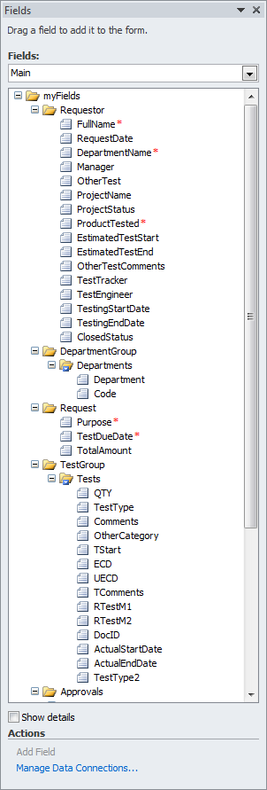 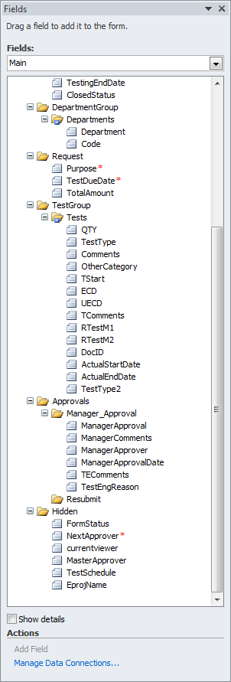

The FormStatus field has a default value of New.

TestSchedule has a default value of False.

EprojName is a value equal to ProjectName. It was created to show the Project Name in emails for project tracking.

## Design of Form Views

An InfoPath file called CompanyTestReq contains all these form views. Below is a brief description of each one for reference or if any modifications are needed. The library is created when the form is uploaded to SharePoint. Where unique, rule creation will be detailed.

**New**



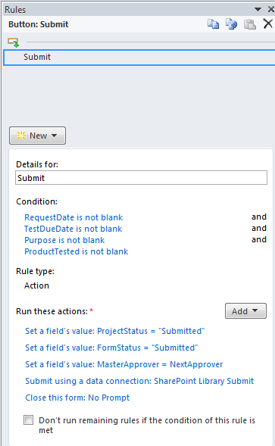

Submit Button Properties

Condition:

Request Date is not blank and TestDueDate is not blank and Purpose is not blank and ProductTested is not blank.

Actions:

Set field ProjectStatus = “Submitted”

Set field FormStatus = “Submitted”

Set field MasterApprover = NextApprover

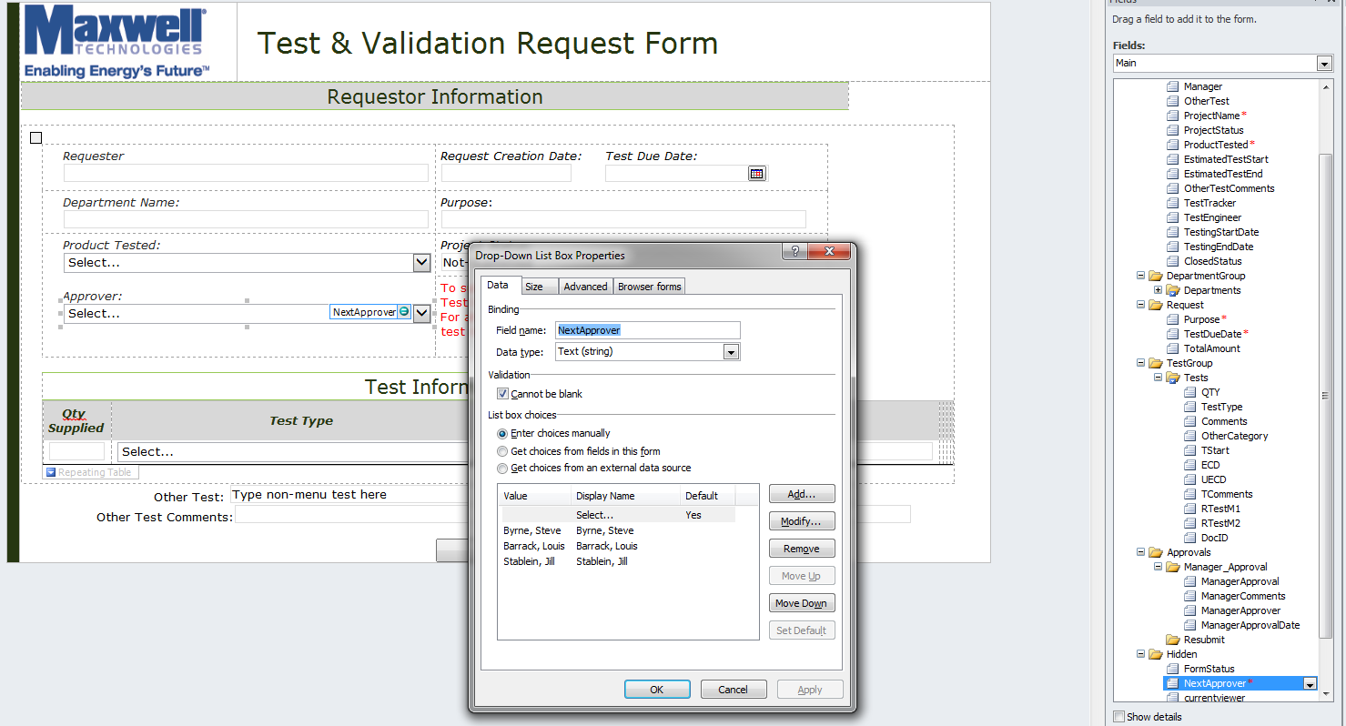

**This is where the approver is initially set. To change the approver name values, edit the properties of the Approver dropdown box and delete/enter a different name. Make sure the name is in Active Directory format with LastName, FirstName. You can check the format by adding it to a Sharepoint security group first.**

Submit using a data connection – SharePoint Library Submit

(This connection is created when you submit the form to SharePoint)

Close this form: No Prompt

**Approvals**



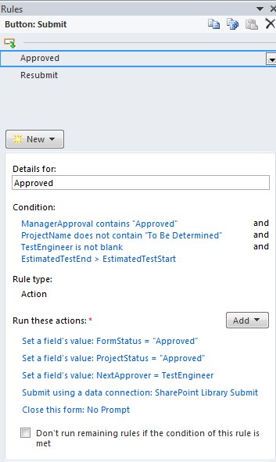 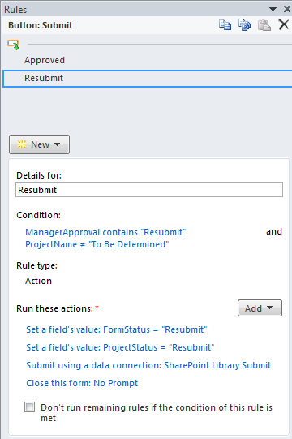 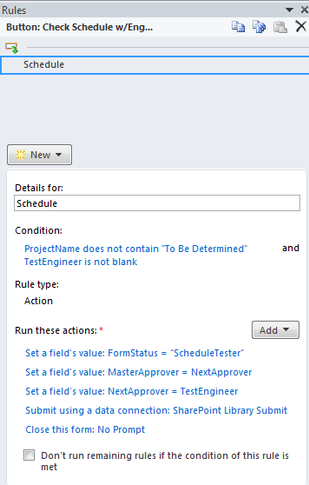

Submit Button Properties

Approve button selected

Condition:

ManagerApproval contains “Approved” and

ProjectName does not contain “To Be Determined” and

TestEngineer is not blank and

EstimatedTestEnd is greater than EstimatedTestStart

Actions:

Set FormStatus = “Approved”

Set ProjectStatus = “Approved”

Set NextApprover = “TestEngineer”

Submit using a data connection – SharePoint Library Submit

Close this form: No Prompt

**Resubmit**



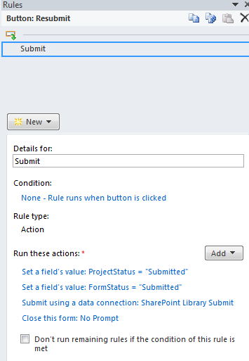

**EmachCheck**



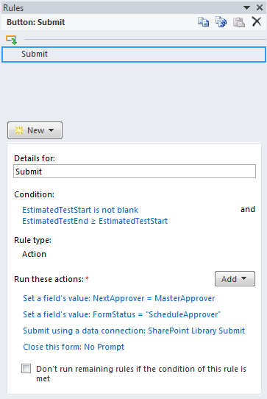

**Test Start**



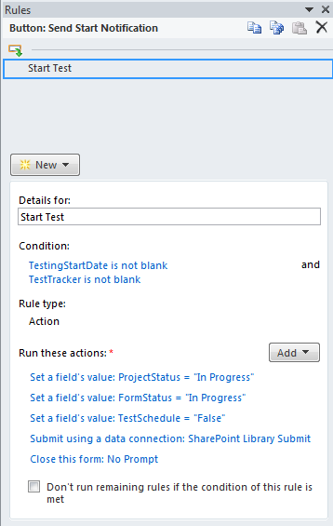 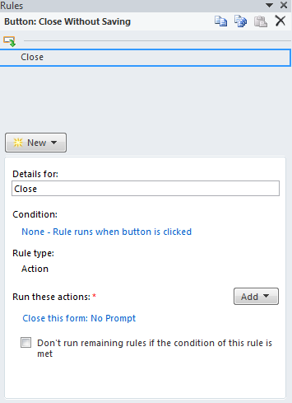

**Testers**



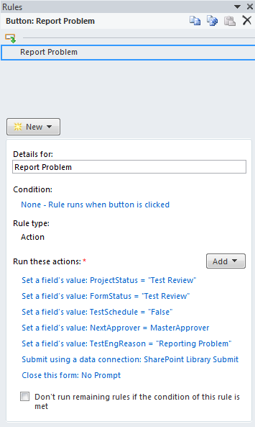 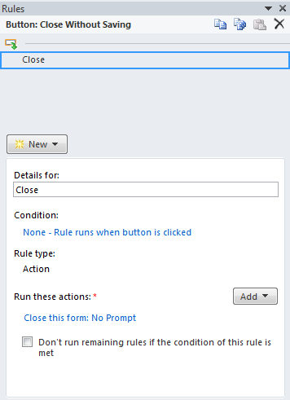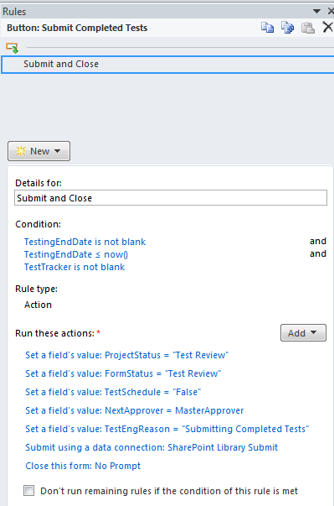

**Final Review**



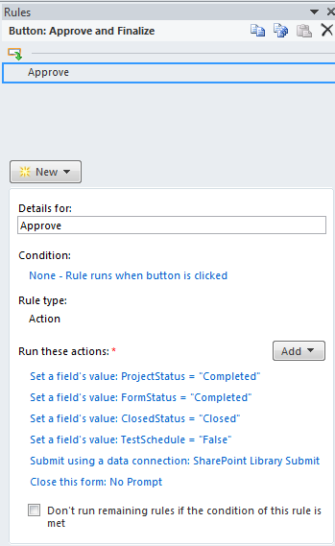 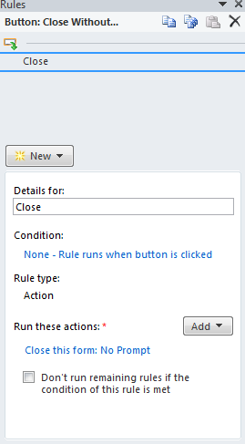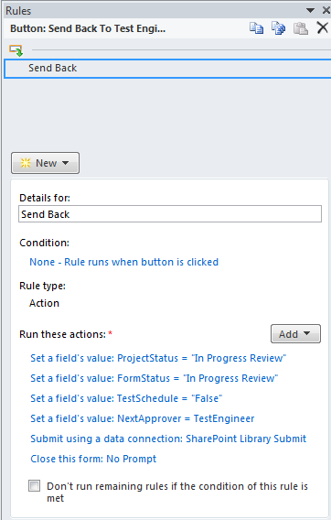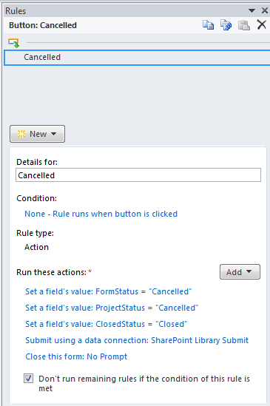

**Testers Read Only**



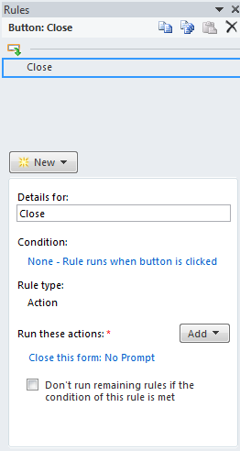 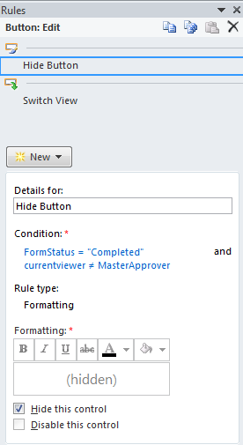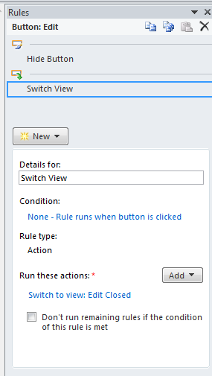

**Edit Closed**



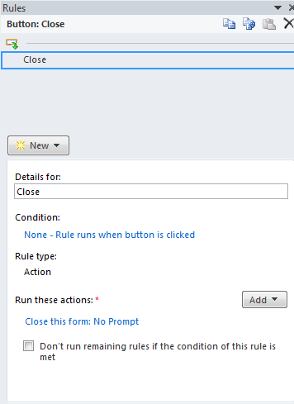 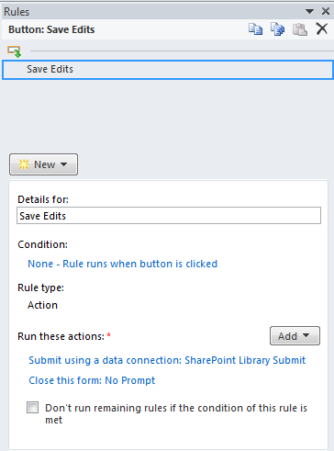

**Test Machine Schedule**



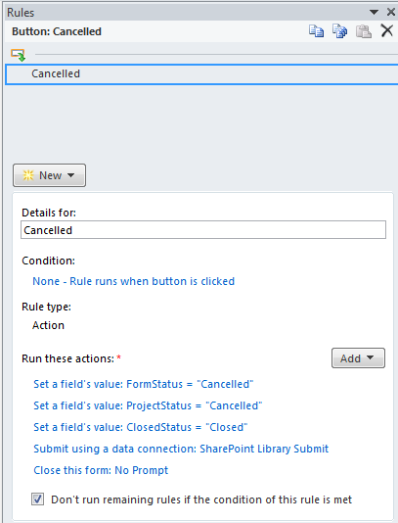 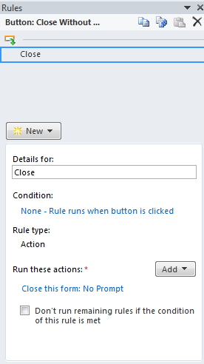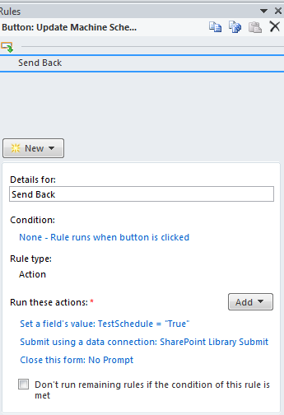

## 

## InfoPath Form Load Rules

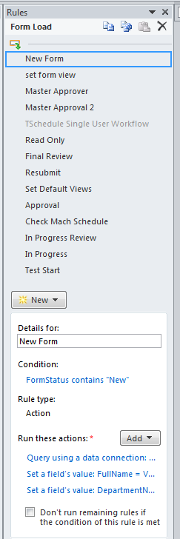

In InfoPath the Form Load rules along with each form’s submit buttons will set the value for the fields Form Status, Closed Status, Test Schedule, Master Approver and the Next Approver. The default value of Form Status is set to New. When a user opens the form, a query is sent to find out who the user is (Form Load rule). Then that user is compared to the Next Approver and the Form Status. Based on the rules, only the correct view will open for the user.

The Form Load Rules

There are thirteen form load rules in this order. When a condition is met, then they run their actions:

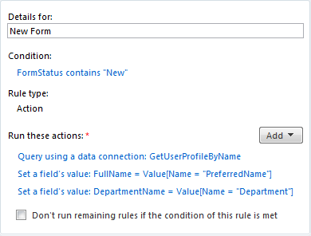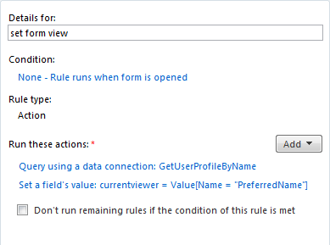

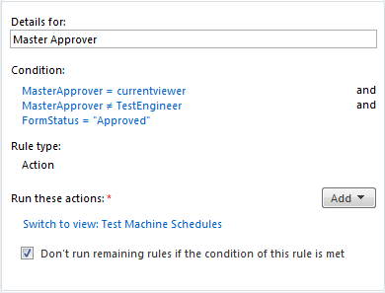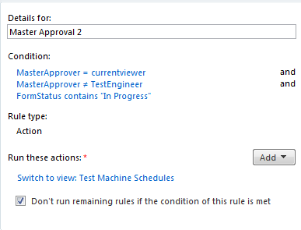

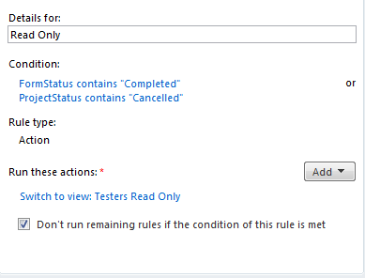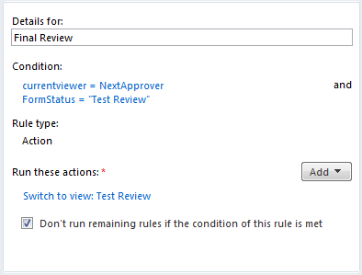

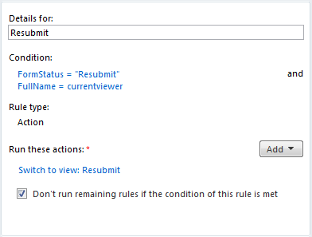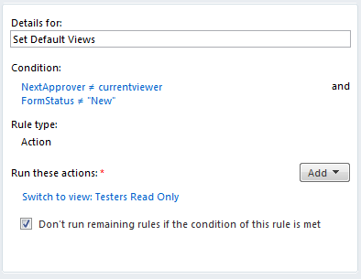

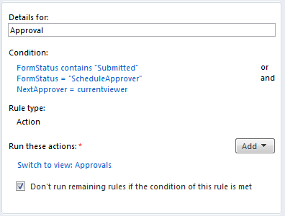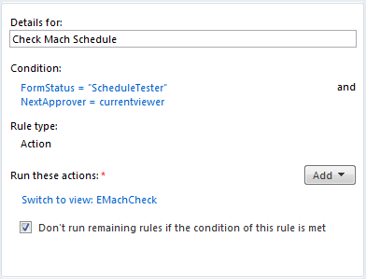

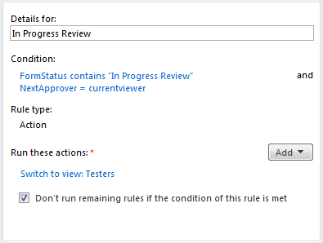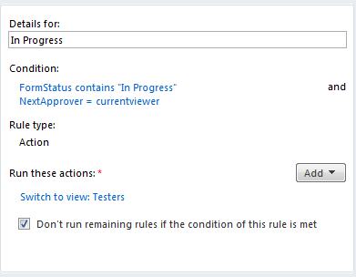

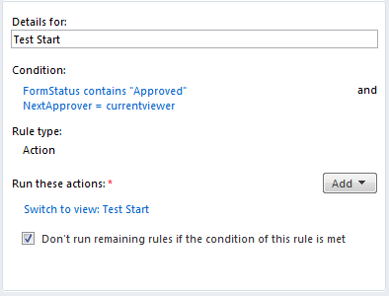

UPLOADING THE INFOPATH FORM INTO SHAREPOINT

In SharePoint save the form as CompanyTestReq.xsn.

Before uploading the file, new column names must be created in SharePoint, Next Approver, Test Schedule, Master Approver, Eproj Name and Form Status as text fields, which was done previously. When the forms are uploaded, SharePoint will assign those existing fields to the new form fields and they will be available to select and use when the workflow is created.

To Publish the form to the SharePoint Site, go to Site Actions – Site Settings and copy the Site URL under Site Information. You will need this to tell InfoPath where to publish your form.

Go to File Menu and Select Publish and then select **Publish form to a SharePoint Library.** This will start the Publishing wizard.

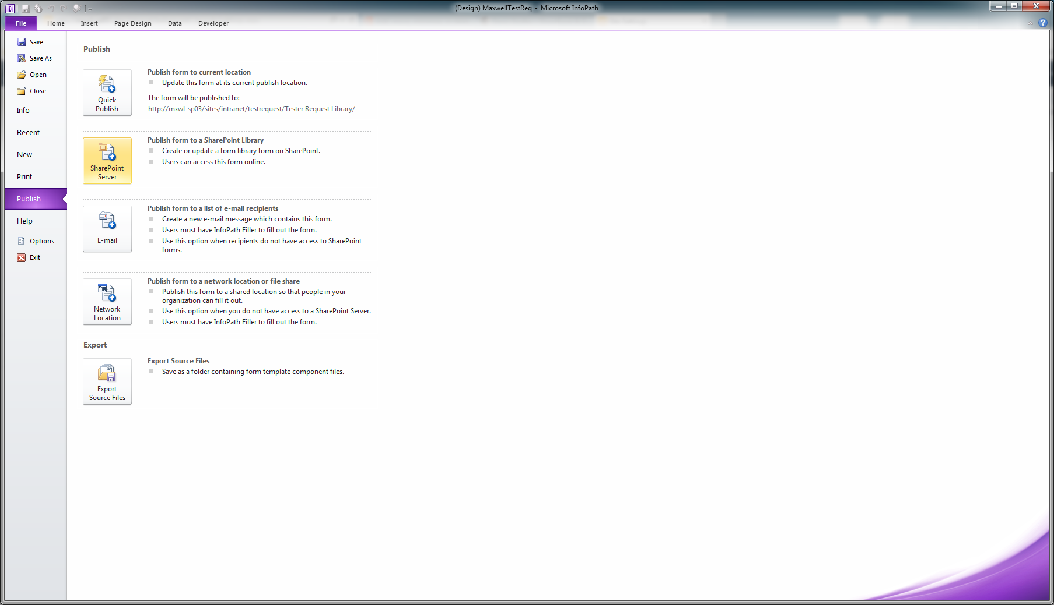

Publish the form with these settings:

For location enter the site URL you copied.



The above shows a link to the library which does not exist – it should just point to the site.

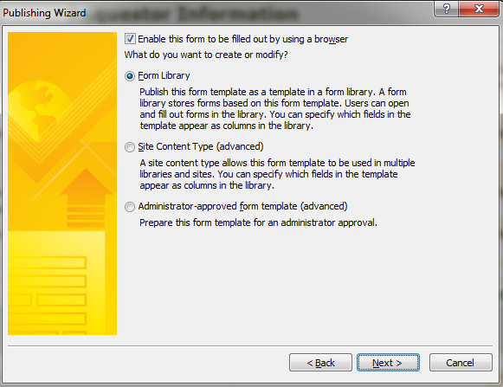

Click Next with the setting above.

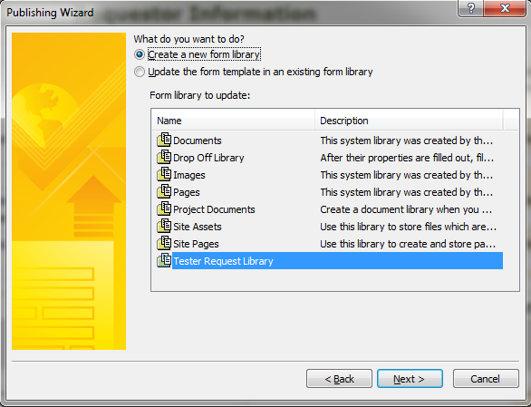

Make sure **Create a new form library** is selected and hit next.

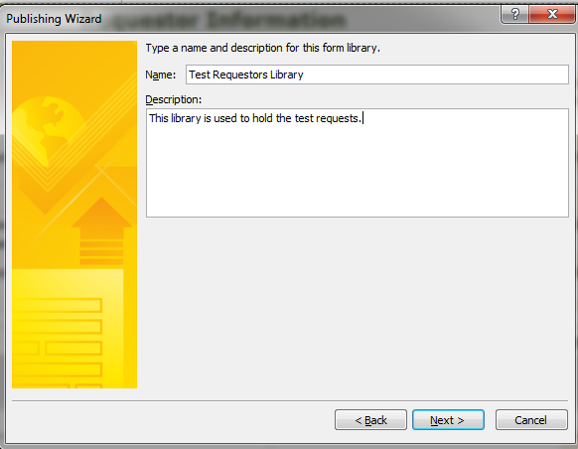

Type the name of your new library and hit Next.

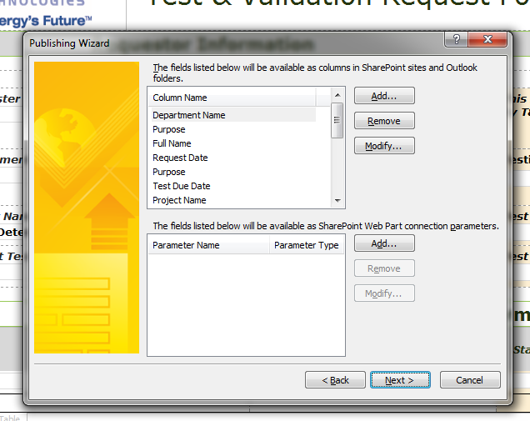

Make sure these fields are uploaded:

Closed Status, Department Name, Estimated Test End, Estimated Test Start, Purpose, Full Name, Request Date, Test Due Date, Project Name, Project Status, Product Tested, Estimated Test Start, Estimated Test End, Test Tracker, Test Engineer, Testing Start Date, Testing End Date

For Form Status, Next Approver, Master Approver, Eproj Name and Test Schedule:

Click **Add**, select FormStatus from the **Hidden** Group and then click **OK**. It should map to the already created Site Column under the Company Group and the **Form Status** column you created earlier. Do the same for NextApprover, MasterApprover, EprojName, TestSchedule and then click Next.



Select **Adjust data connections to new location (this is very important)** and then click **Publish**.

Once the form is loaded go to the newly created library and go to **Library** – **Library** **Settings** – **Advanced** Settings and select **Open in the browser** and then save.

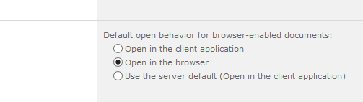

If this is not enabled the form will not open in the browser. To test, while in the home page of the library click on Add New Item, the InfoPath form should open.

## Building the Workflow

With the InfoPath form loaded into the newly created library, now a workflow can be created and attached to the form. Workflows are initiated either manually, on creation of a new form or an update to the form. You can also select a combination of these. The workflow will be created in SharePoint Designer because it has more robust tools for creating workflows, even though this is a very simple workflow.

In SharePoint, go to your new library and select the Library tab – Workflow Settings



Make sure you have SharePoint Designer installed. This is a free download from Microsoft.

Select Create a Workflow in SharePoint Designer

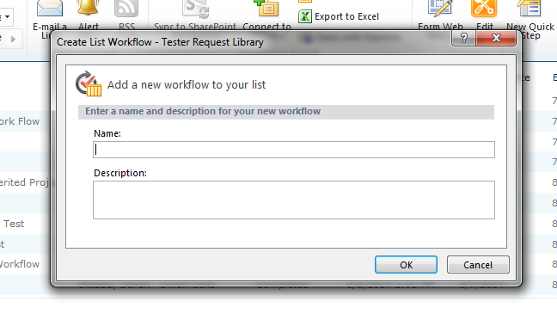

A window opens. Enter your new workflow name and a description then hit Next.

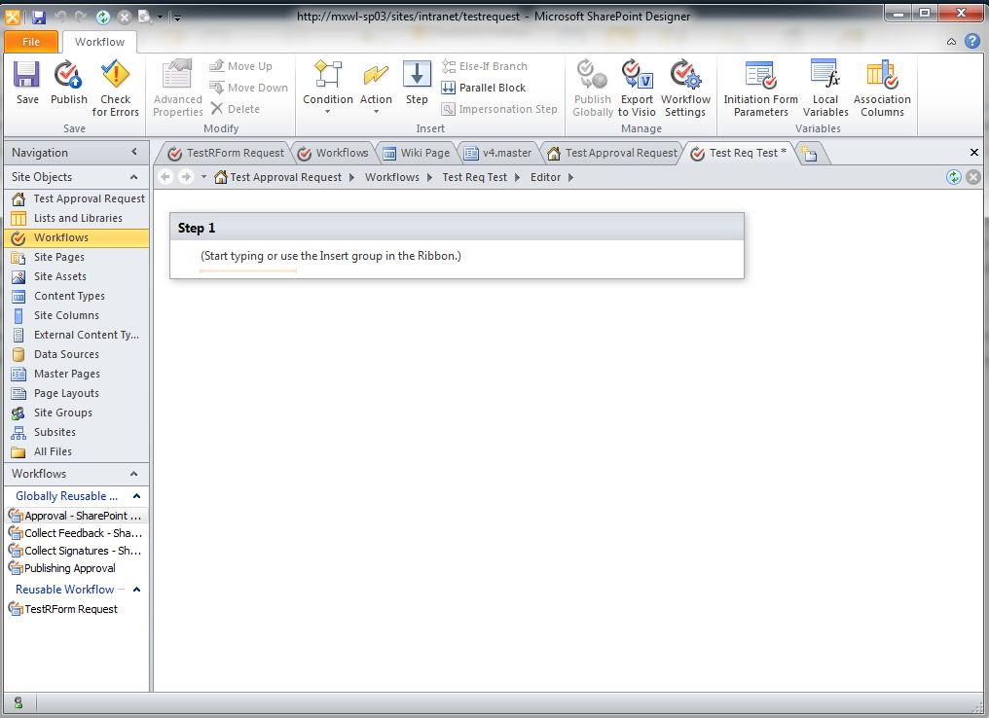

This is where the workflow will be built.

In this workflow the users will be sent a link to the form for easy navigation. To create this link a workflow variable will need to be created. Under the **Action** menu select **Set Workflow Variable**.

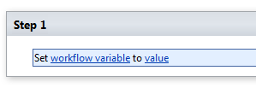

Click on workflow variable and then choose **Create a new variable**. 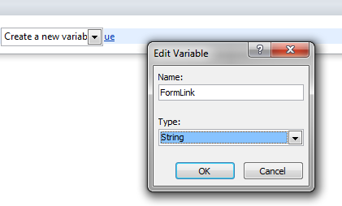

Name the new variable FormLink as string and then click **OK**.

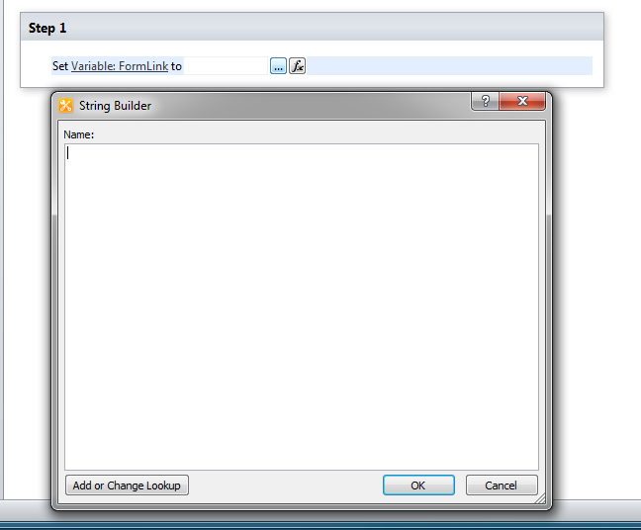

Click Value, click the ellipsis (…) button, and then open the string builder.

Type in this general URL:

**CurrentSite**/_layouts/FormServer.aspz?XmlLocation=**CurrentItem**&Source=**CurrentSite**&DefaultItemOpem=1

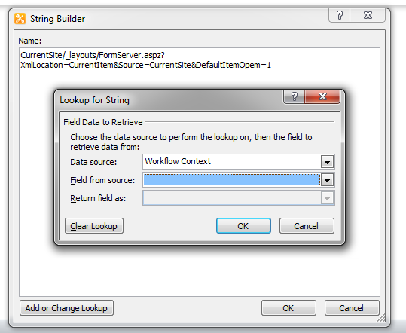

Each bold text item is a lookup you will replace by clicking on **Add or Change Lookup**.

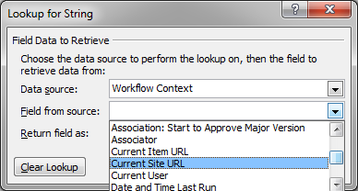

Highlight each text in bold and select the appropriate item from the dropdown and hit ok. When completed add the additional text to create a hyperlink.

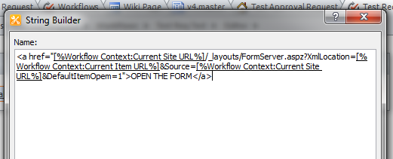

Click **OK** when done.

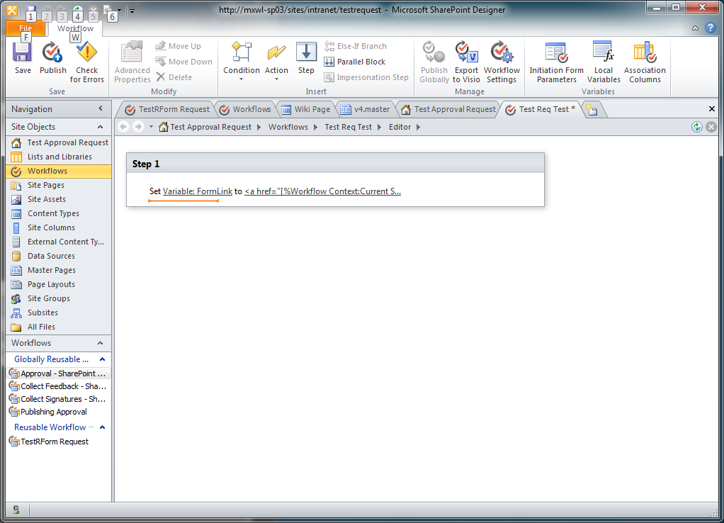

Your workflow will look like this. Because this workflow will use site columns, click the **Association Columns** button and use the **Select Site Column** button to add all the Company Group site columns: Form Status, Master Approver, Eproj Name, Test Schedule and the Next Approver columns and then click **OK**.

To add the first condition of the workflow, with the curser below the **Set Variable** text, use the **Condition** button to add a condition called **If current item field equals value**.

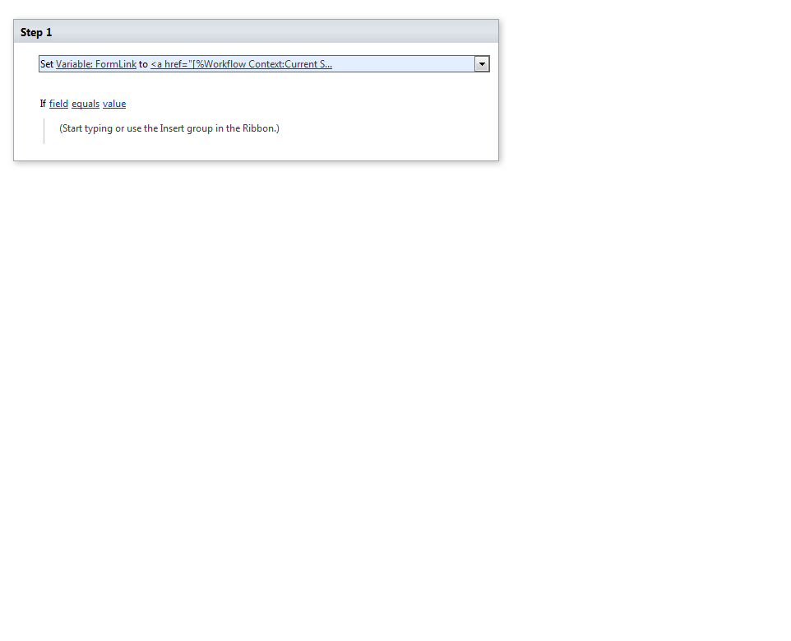

This is how it should look.

With the curser underneath the “Start typing or use” text click on the Else-If Branch button.

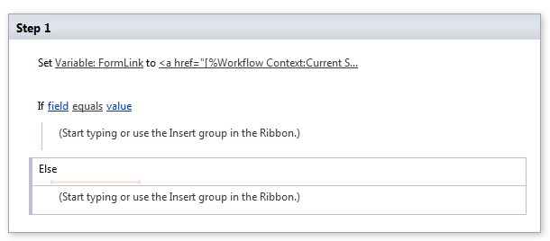

With the cursor in the Start typing section click on the Condition button and again select **If current item field equals value.**

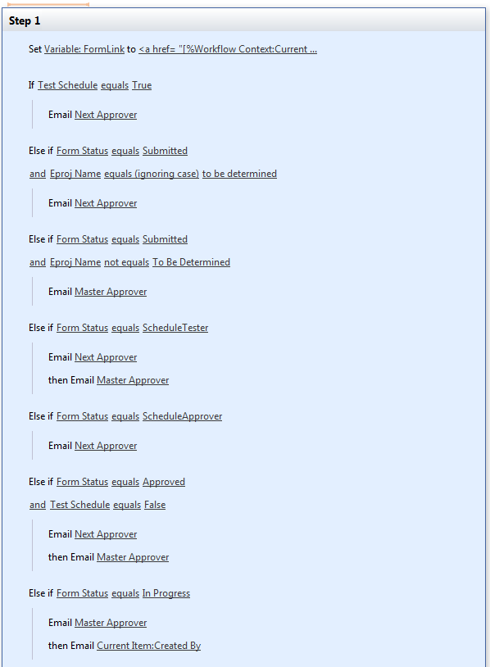

Repeat the last two steps nine more times until there are a total of ten Else If conditions in the workflow.

On the second Else if statement click right under it so a blinking gold line appears and from the **Condition** menu dropdown select **If any value equals value.** An And statement should appear.

Skip one Else If and the add And statements to the next two Else If statements.

In the Start typing portion click the dropdown from **Action** and select **Send an Email.**

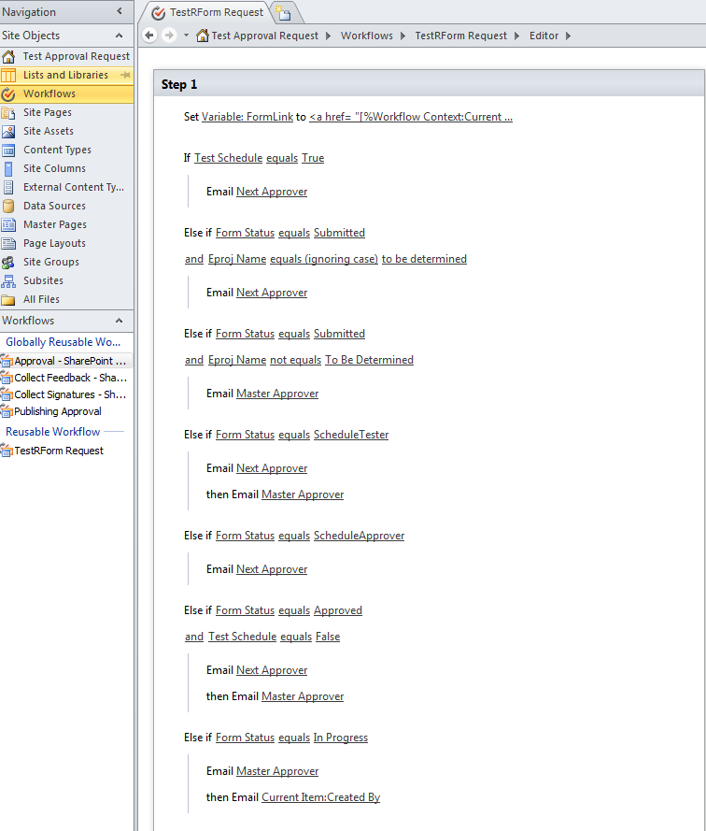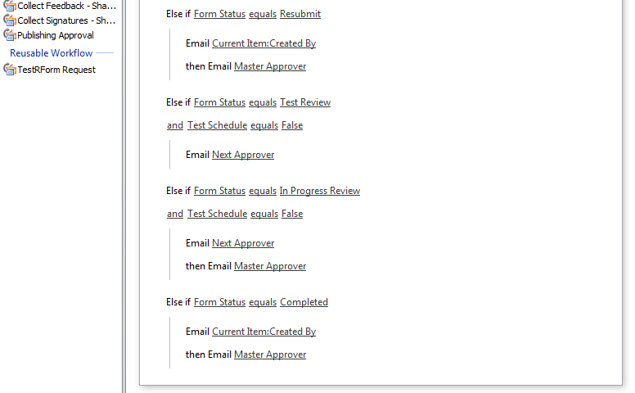

Continue adding the **Send an Email** until the workflow looks similar to this with more Else if statements.

The And and Email statements will be blank until they are filled out.

Starting at the top, click on field and select Test Schedule. Leave equals. Click on value and type in True.

The next statement is an Else IF statement, click on field and select Form Status. Leave equals. Click on value and type in Submitted. Finish the rest of the Else If statements from the screenshot. The and statements are filled the same way.

**For the emails:**

If Test Schedule equals True:

Email to: Next Approver

Subject: Test Machine Schedule/Reschedule Change.

Body: Please review the changes made to the schedule. Check on the link below to review.

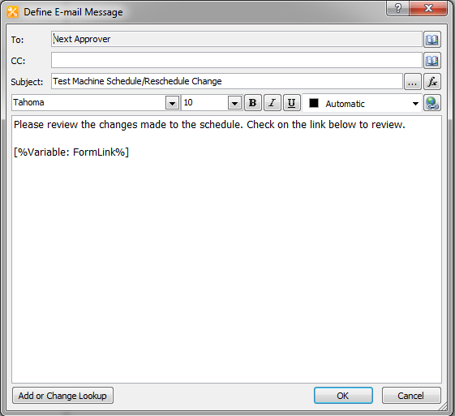

Click on Add or **Change Lookup** at the bottom of the window 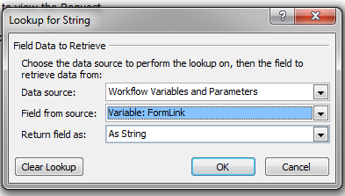

Fill out the window above. This will add a link to the InfoPath form. Hit OK and then OK again to close and save it.

**This link will be added to all the emails.**

The only change to the next email is the wording and Next Approver should be the recipient.

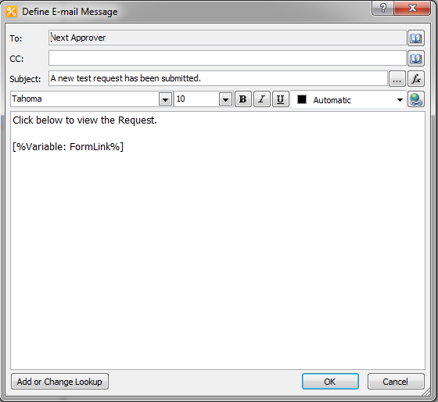

Make sure to add the FormLink. Again, hit OK to close and save it.

For the next email to the Master Approver:

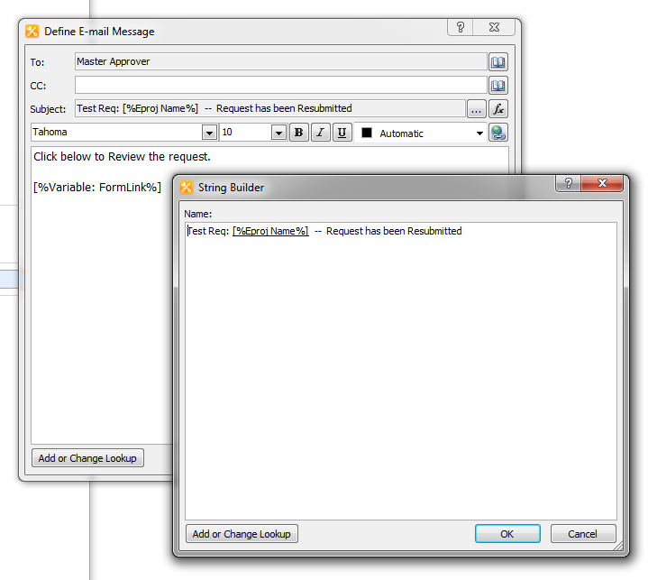

Adds the Project Name to the Email subject line.

The next **Else IF - and** statements sends out two emails.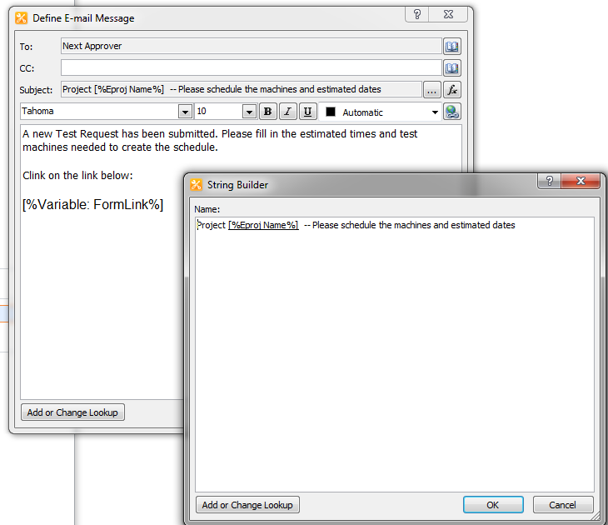

To the Next Approver

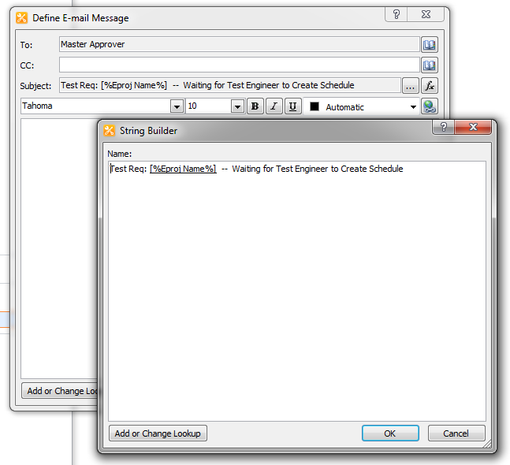

And the Master Approver

The next **Else IF** is for theScheduleApprover status

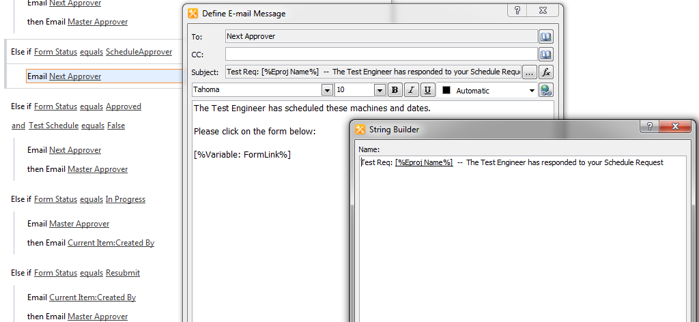

To the Next Approver

The next **Else IF – and** is for theForm Status and Test Schedule values

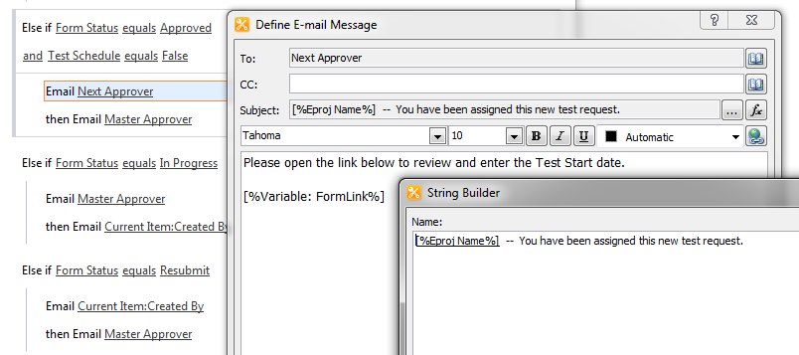

For the Next Approver

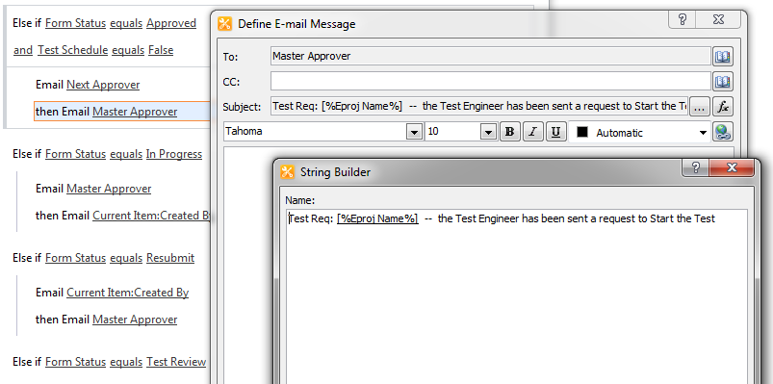

For the Master Approver

The next **Else IF** statement sends out two emails.

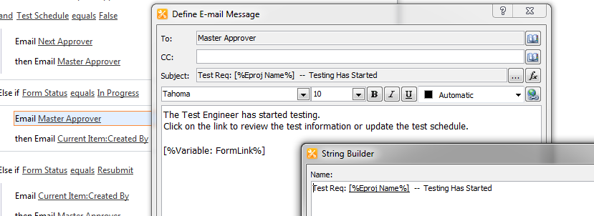

To the Master Approver

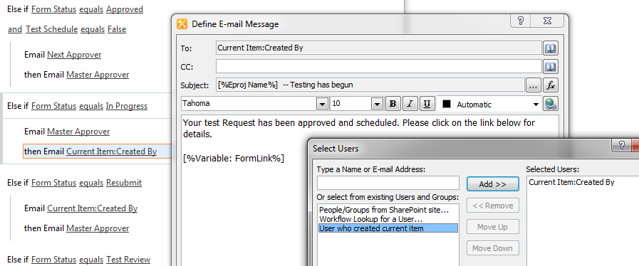

The second is to the user who sent the initial test request. They are identified as CurrentItem:Created By

For Else If Resubmit

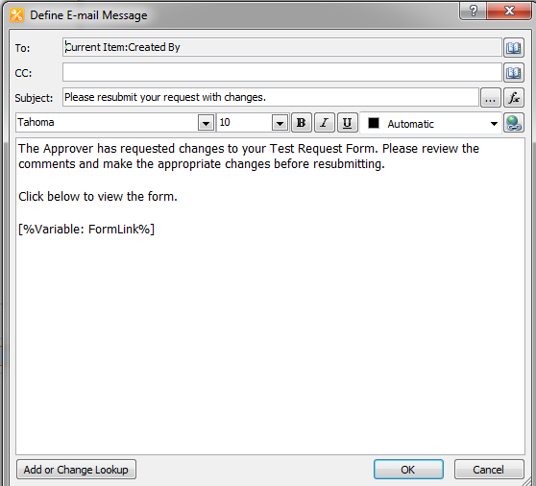

To the Requester

And

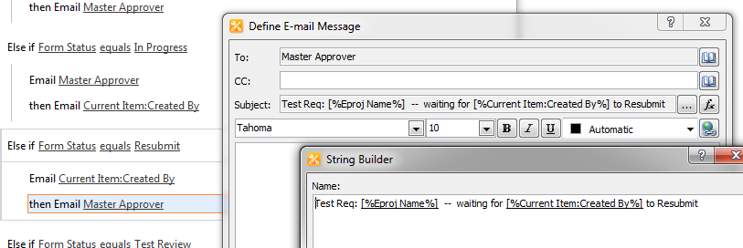

To The Master Approver

For Else If Test Review

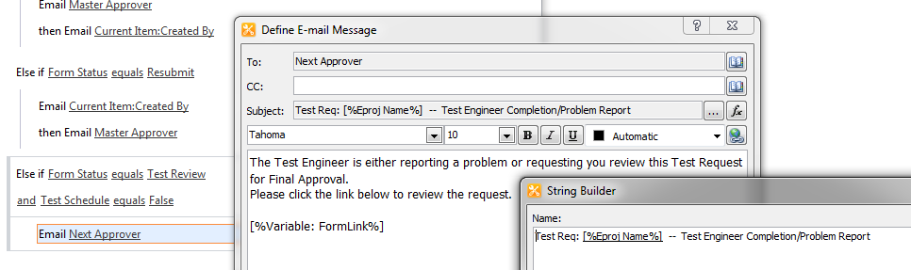

To the Next Approver

For Else If In Progress Review

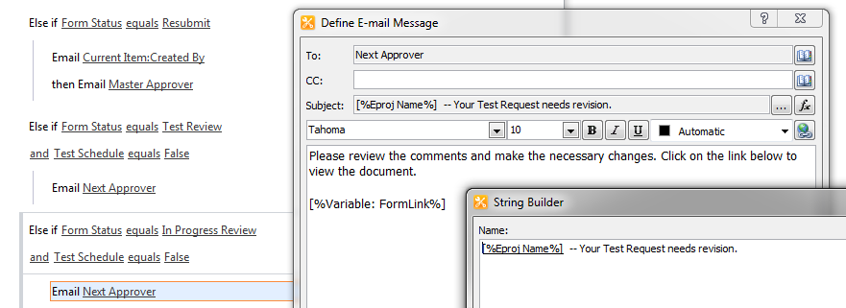

To the Next Approver

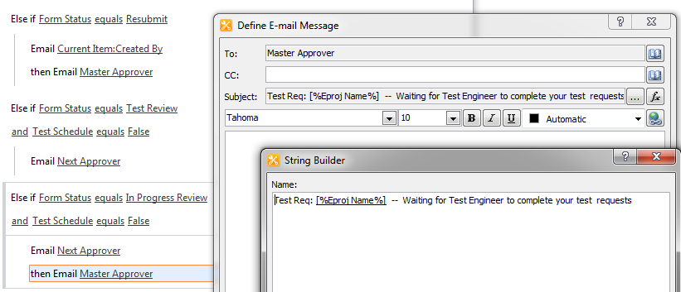

And the Master Approver

For Else If Completed

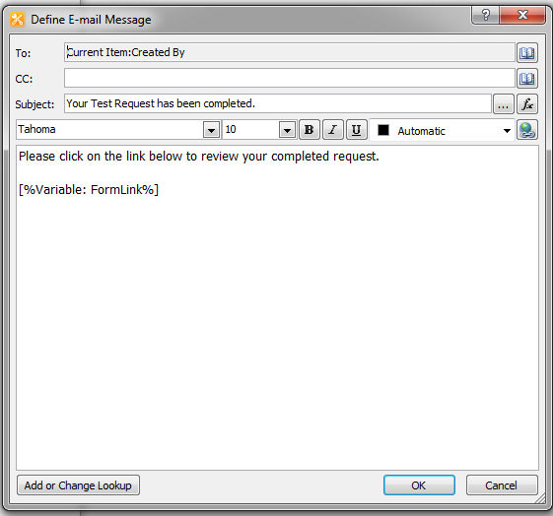

To the Requester

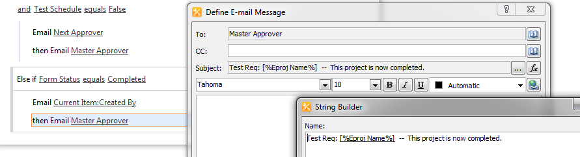

And the Master Approver.

In the upper left corner hit save.



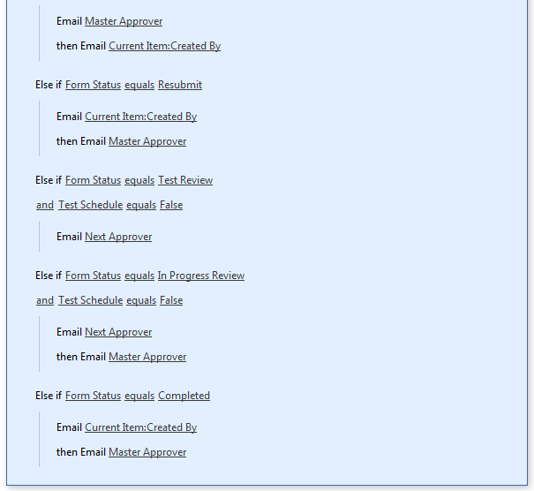

Completed workflow

## Creating the Site Content

The Test Approval Request site contains two libraries, the Tester Request Library where the test request items are stored, and the Test Machines Schedule where the schedules of the test machines are stored. The two list libraries are linked together by the Project Name in both libraries.

The Tester Request library is created when the test request Infopath form is uploaded into the site. Once the library exists, multiple report list views can be created using any set of the library fields. The views can be downloaded into Excel. A calendar view can also be created for the scheduled tests. All views can be filtered to show specific content –items submitted by the current viewer, items that have a date range or a completion status or different calendar views. The library can have different view items showing at once if they are added to its web parts page using the page editor.

## Tester Request Library Setup

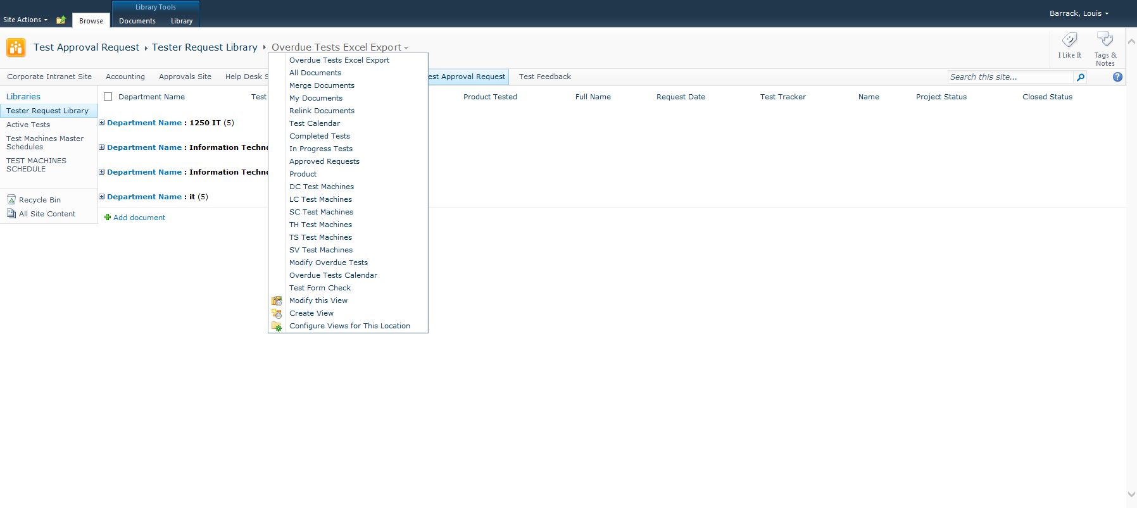

The Tester Request Library with the different report views dropdown. In the dropdown you can pick the list views you created and also choose to Modify, Create and Configure Views for this location. Select Create View.

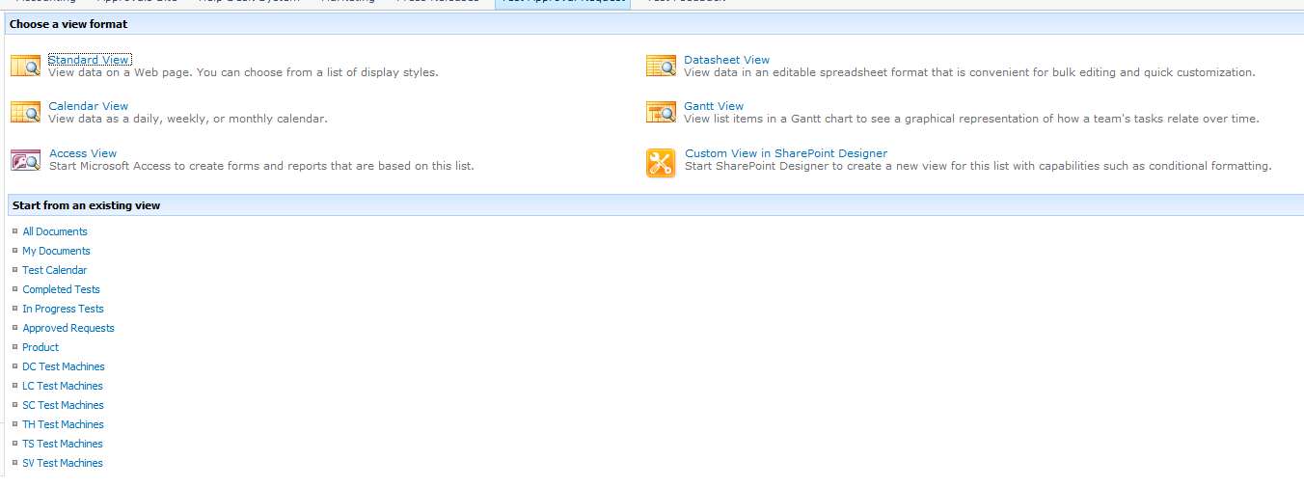

From here you can create different types of views including calendar views and views based on existing views.

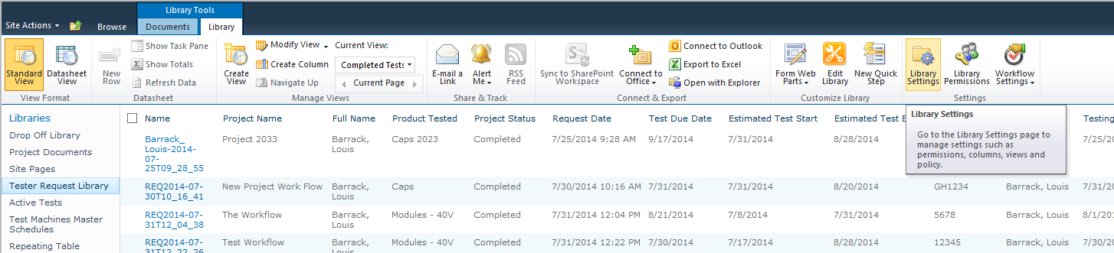

The top bar holds the library toolbar tab. Select Library Settings.

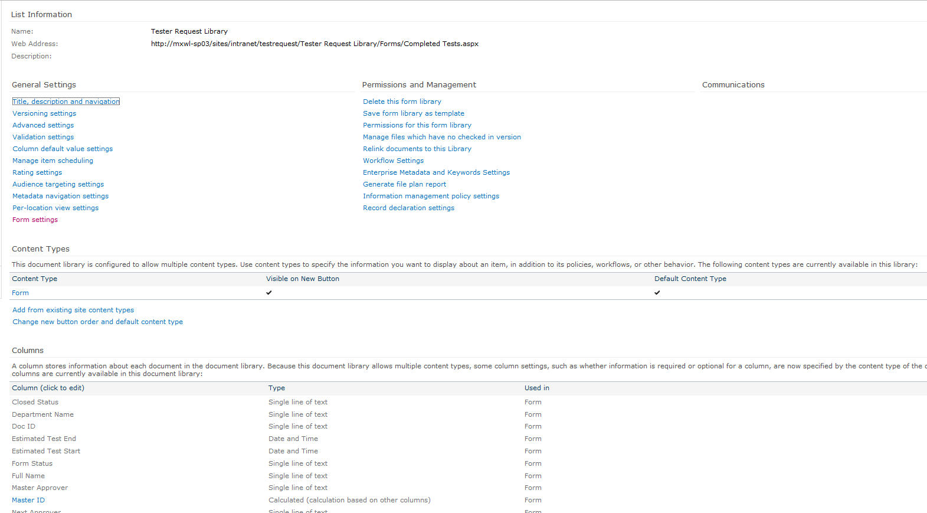

At the top under General Settings select Title, Description and Navigation

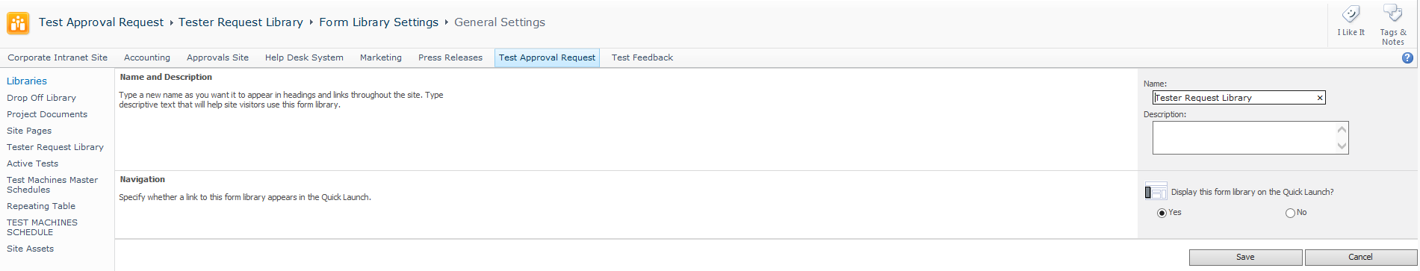

Make sure that Display this form library on the Quick Launch is selected. Click Save.

Under General Settings, select Advanced Settings.

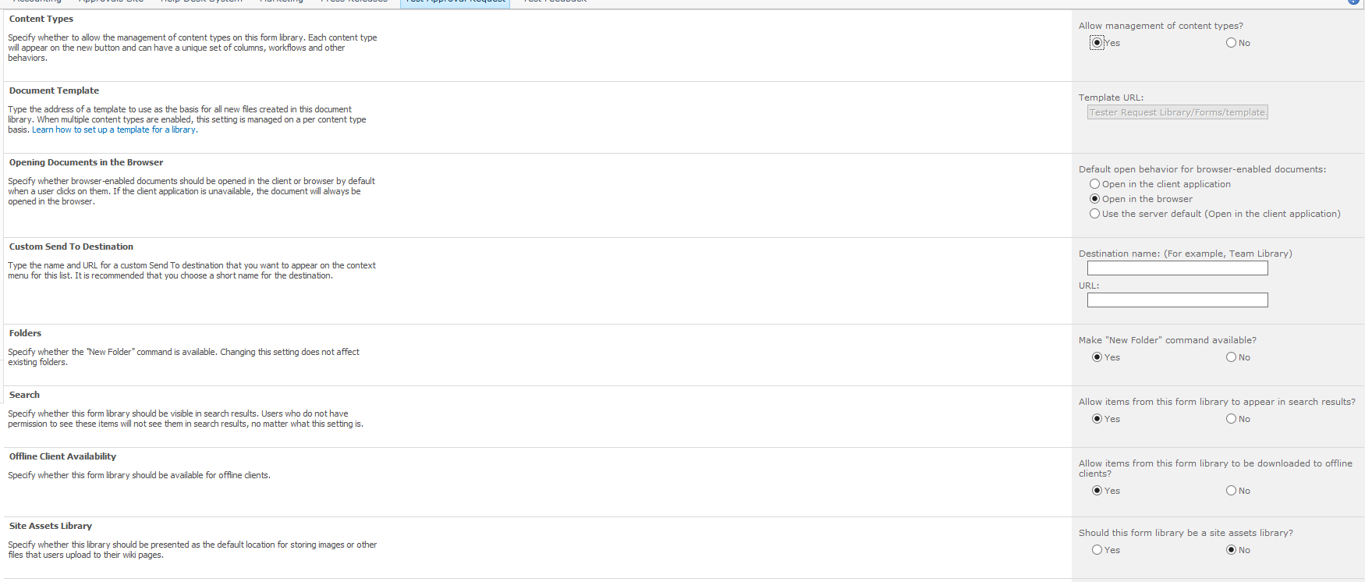

In Opening Documents in the Browser, make sure that Open in the browser is selected. Otherwise another program other than the browser may try to open the form. At the bottom of the page hit Save.

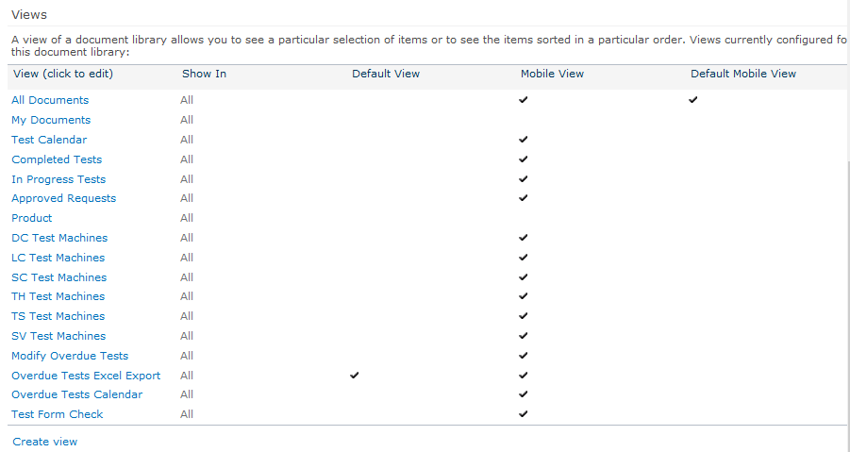

At the bottom of the Site Settings screen is a list of Views. Underneath is the Create View link. The default view is Completed Tests. Click on Create View.

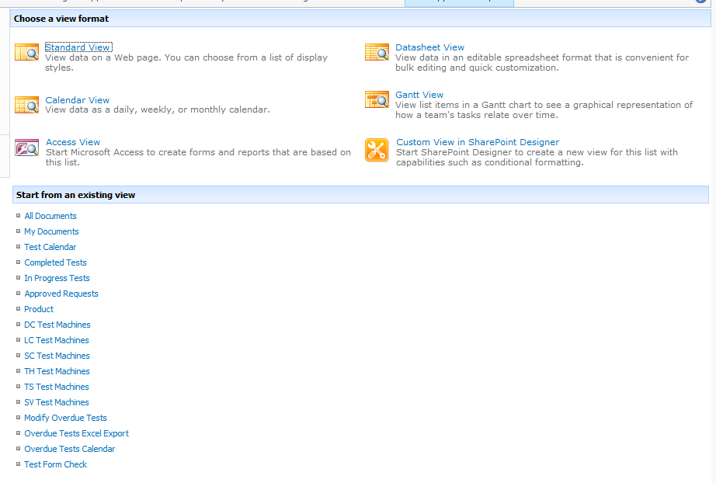

Building a View from an existing View saves a few steps. If you were building a view to see only the documents you created, You could start with My Documents. We want to see everything so we will start with All Documents. Select the link.

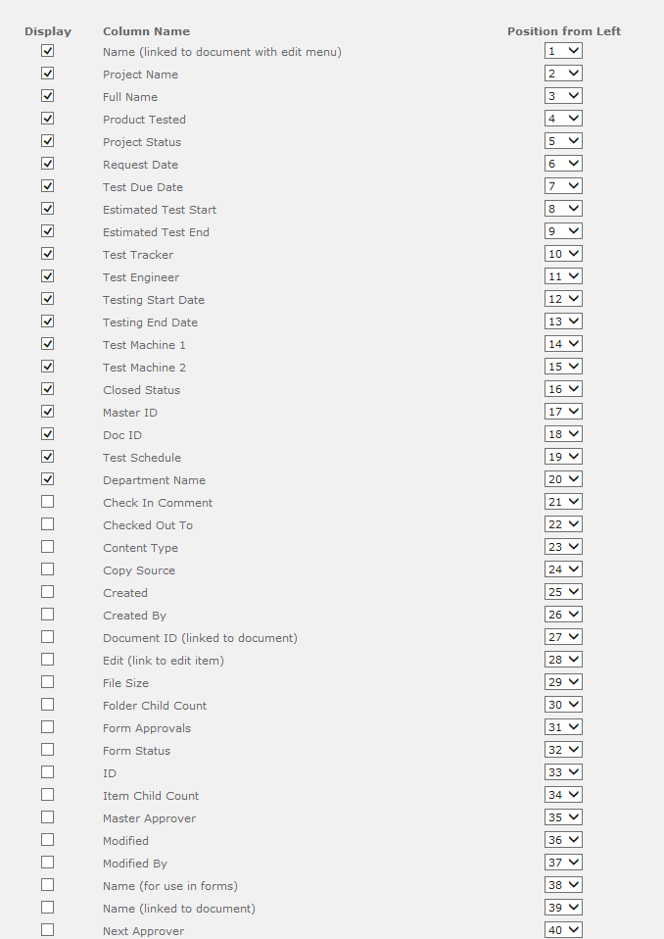 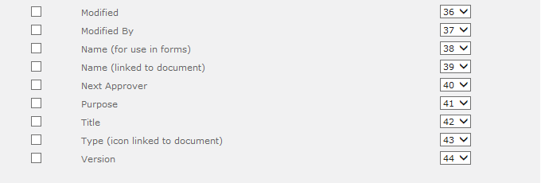

This is the Create View screen. Give it a name, Completed Tests. Check Make this the default view.

This view will show only tests in a Completed status.

Under columns, there is a Display checkox and a Position Order for each column.

Make sure you select and match the column setting with the above. Only the ones checked matter for column order.

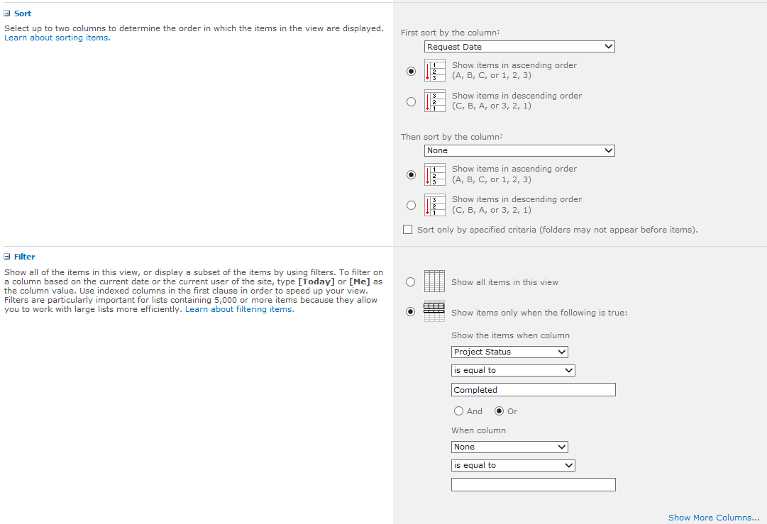

Under Sort, select Request Date to order by the date the request was generated.

Under Filter, set Project Status equal to Completed.

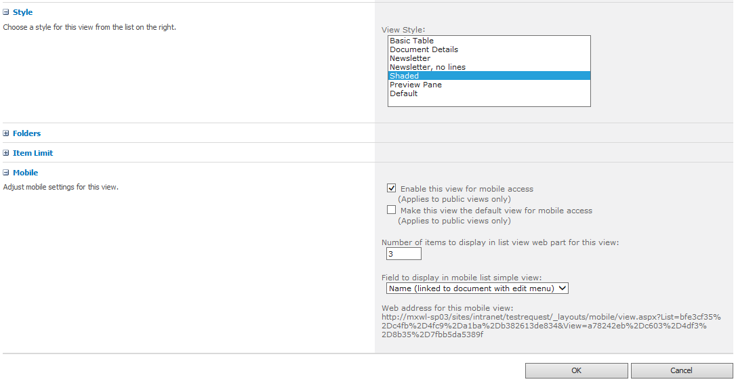

Under Style select Shaded to highlight every other row.

Hit OK to save.

For the site, two more views need to be created. Select modify Completed Tests.

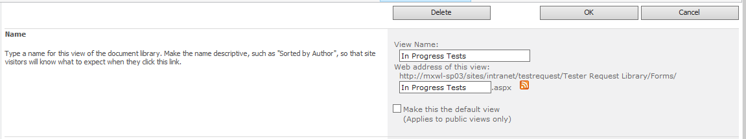

Name this one In Progress Tests.

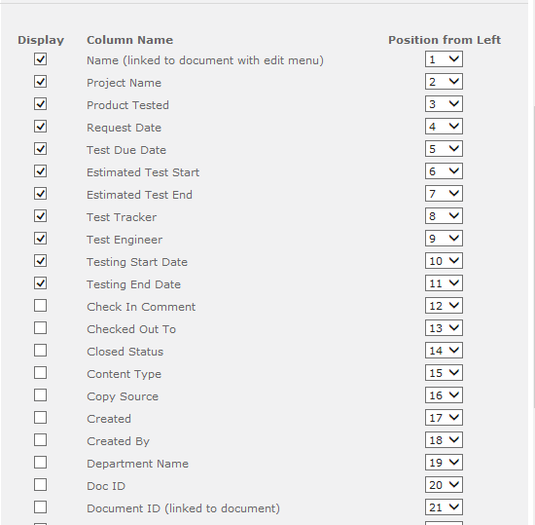

Setup the columns as above.

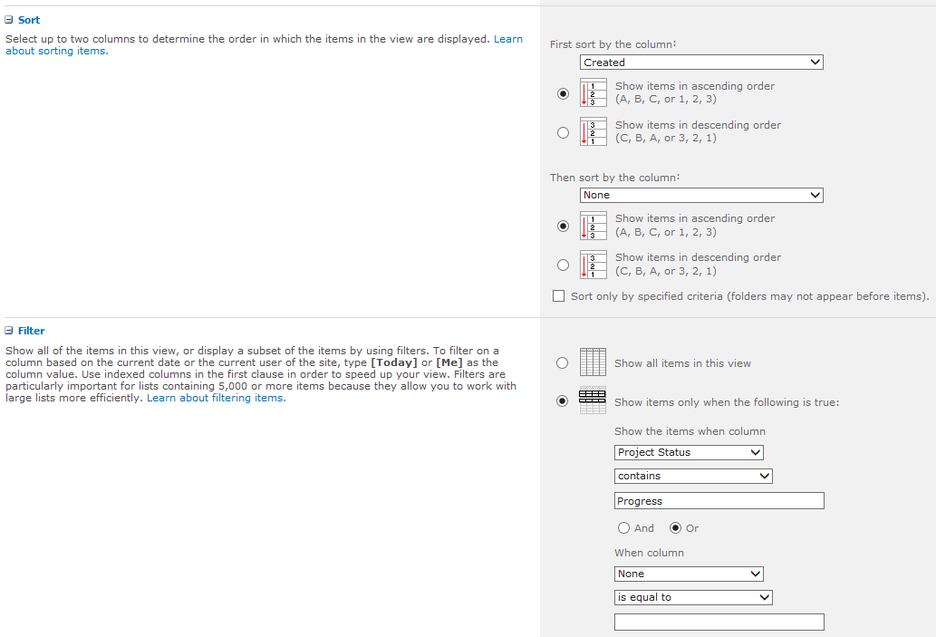

Sort by Created.

Set Filter to Project Status contains Progress



Under Style select Shaded to highlight every other row.

Hit OK to save.

The next view is a Calendar View. From the View drop down select Create View.

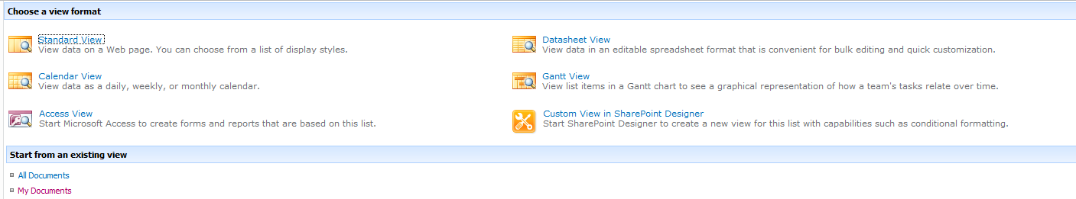

Select Calendar View.

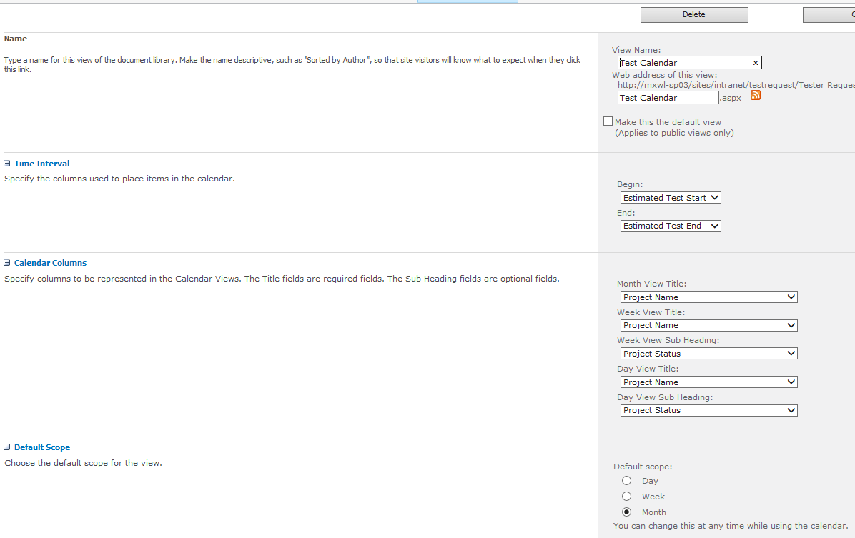

Name this Test Calendar.

For the Time Interval:

Begin: Estimated Test Start

End: Estimated Test end

For Calendar Columns:

Month, Week and Day Title: Project Name

Week and Day sub heading: Project Status

Set Default Scope to Month.

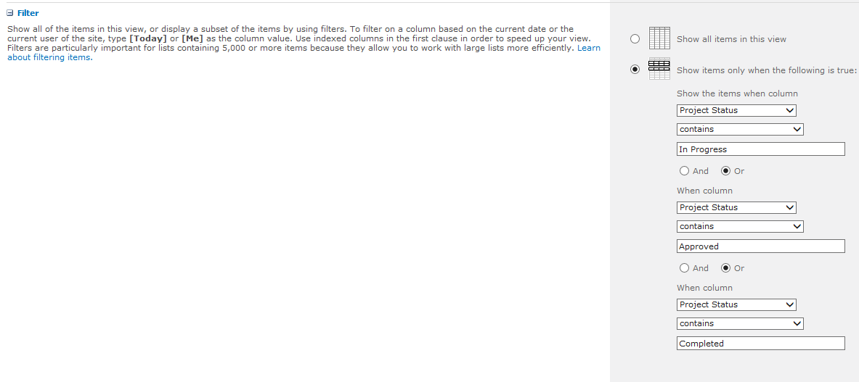

For Filter:

Project Status contains In Progress

Project Status contains Approved

Project Status Contains Completed

Hit OK to Save

## The Site Homepage

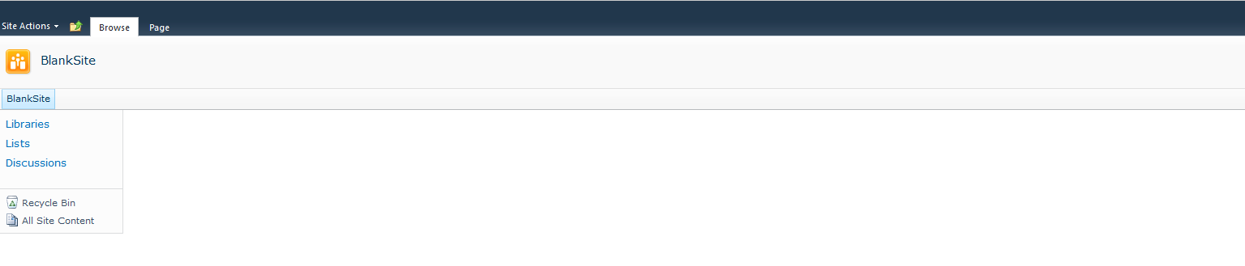

This is the default generated SharePoint site Homepage.

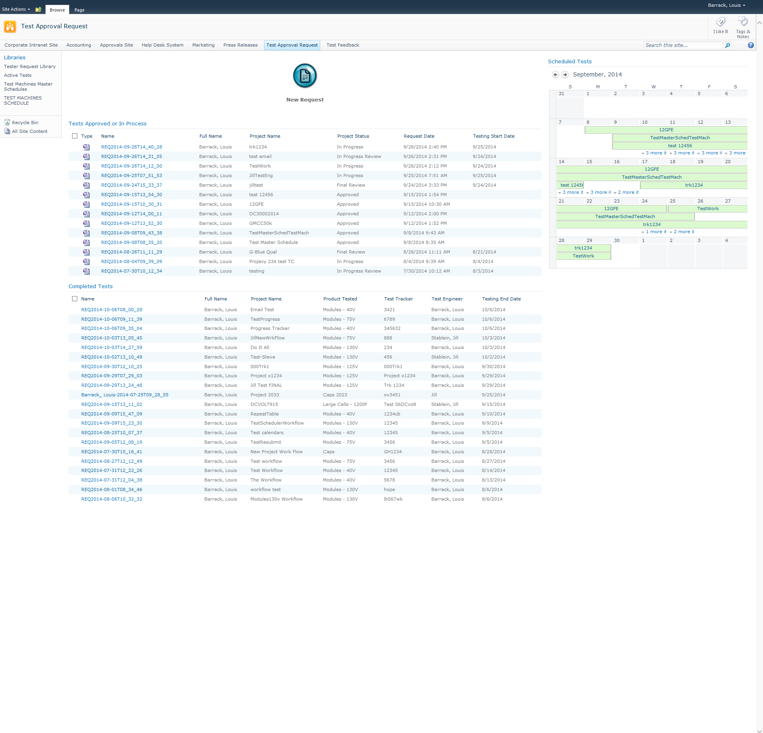

This is what the site will look like when done. On the navigation either on the top or to the left go to the site Homepage.

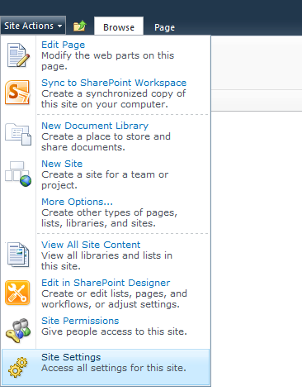

Select Site Settings from under the top black ribbon on the left menu Site Actions.

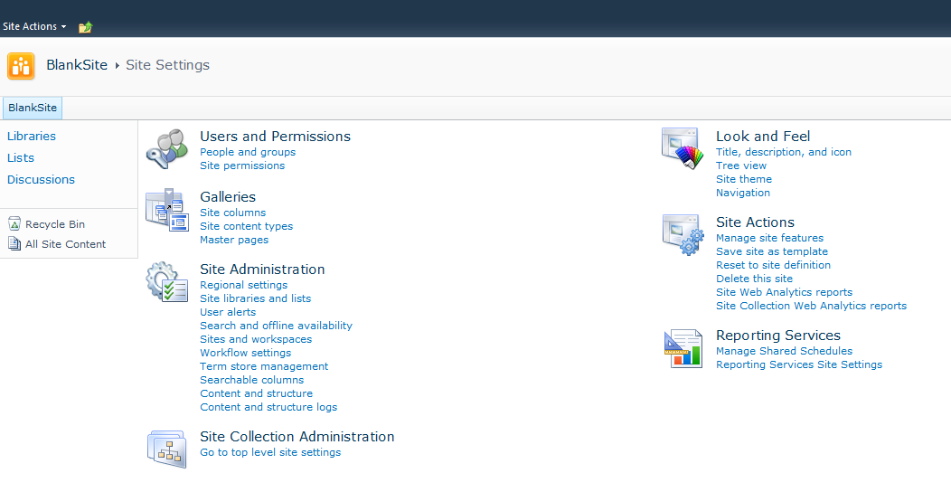

Under Look and Feel, select Navigation.

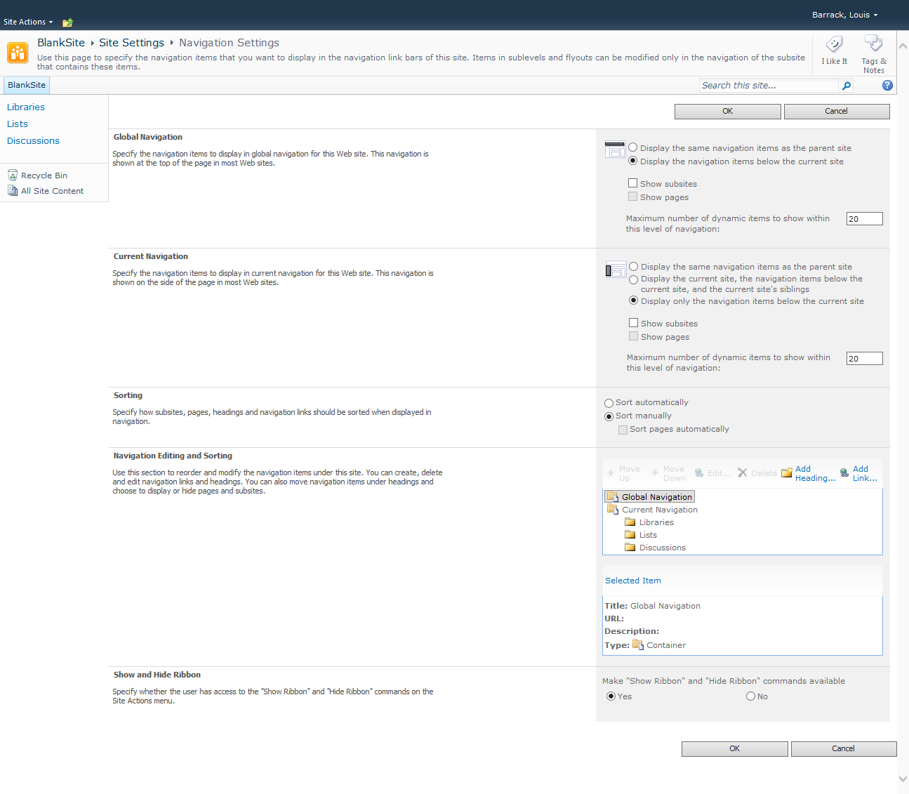

Under Current Navigation, select Display the current site, the navigation items below the current site, and the current site’s siblings.

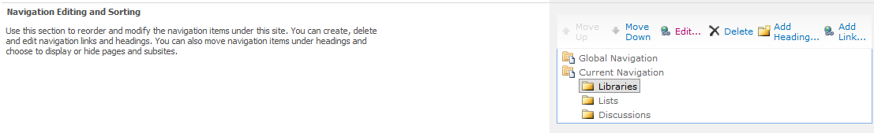

To the right of Navigation Editing and Sorting select the Libraries folder under Current Navigation.

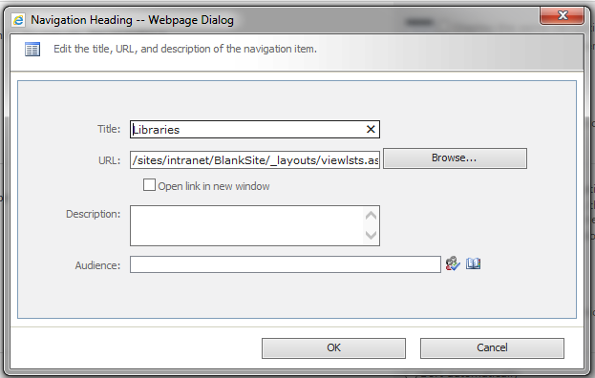

Add the Approvers security group. This will hide the link to the libraries from all other users in this site (Test Requesters and Testers). This does not deny access to the libraries. Hit Ok and then Ok again. You can now click on the site link to the left to go to the homepage.

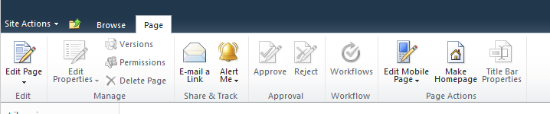

On the top menu, select Page and then to the right Edit Page.

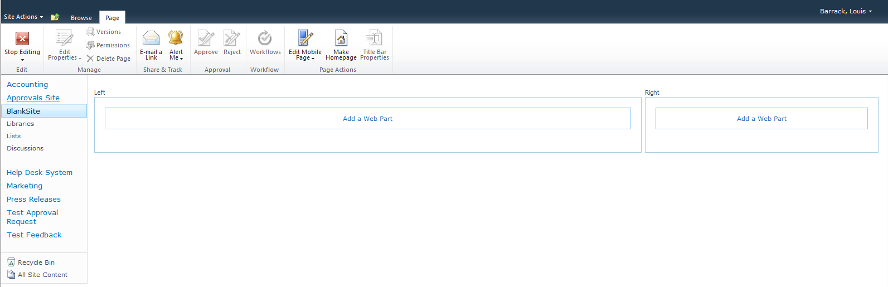

This is the Web Part page. You can add content from this or other sites to the Web Parts. Click on the Web Part to the left.

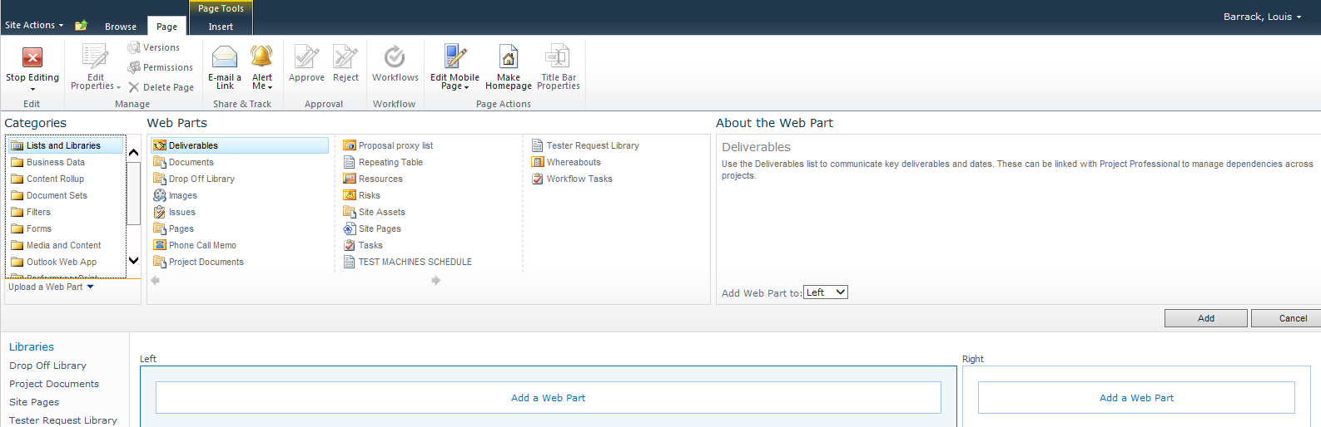

Select Tester Request Library and make sure you are adding it to the Web Part to the left. Do the same thing again, it will add another list to the newly added one. Do the same thing for the Right web part.

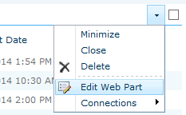

In the section on the topmost left web part move the mouse over to the right corner to show the drop down arrow. Select Edit Web Part.

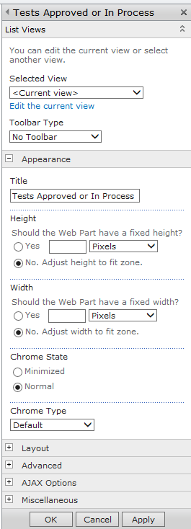

Change Toolbar Type to No Toolbar

Set Title to Tests Approved or in Progress

Set Chrome type to Default.

Under Selected View select In Progress Tests

Click Apply.

Click edit the current view.

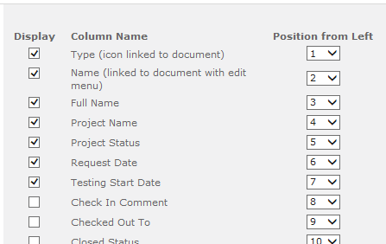

Set the columns to match above.

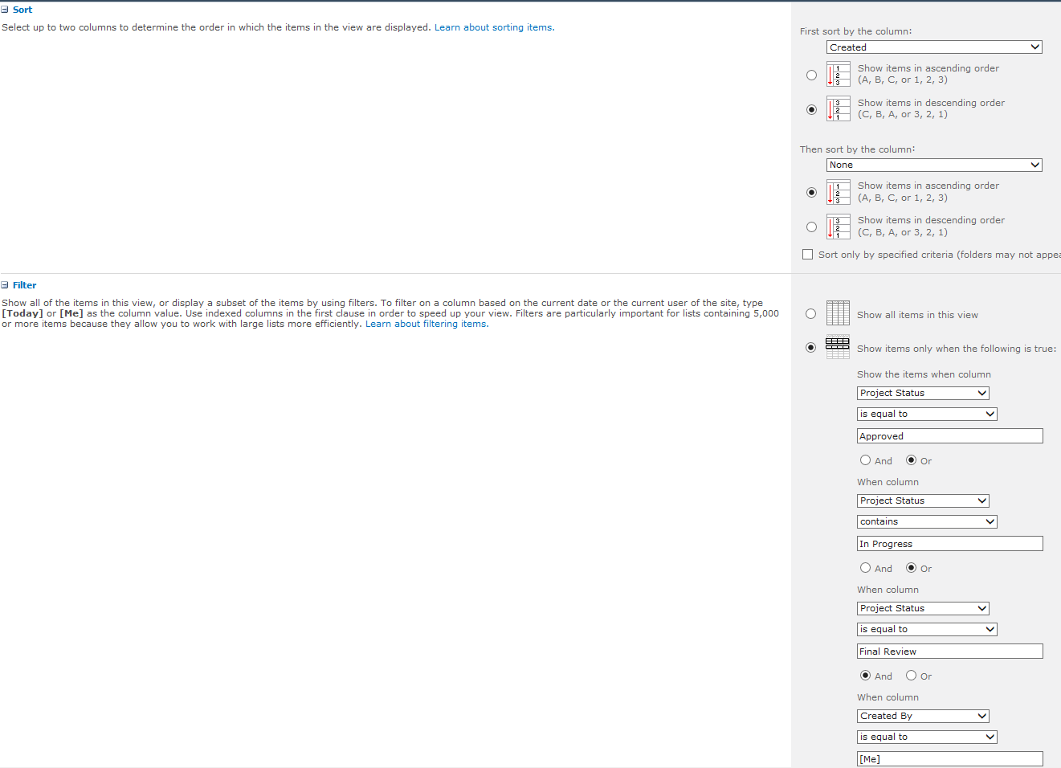

Sort by the column Created

Filter is set to:

Project Status is equal to Approved or

Project Status contains In Progress or

Project Status is equal to Final review and

Created By is equal to [Me]

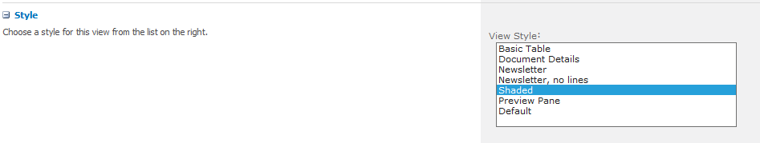

Set style to Shaded.

Click OK to save.

On the list just below follow the same steps with these exceptions:

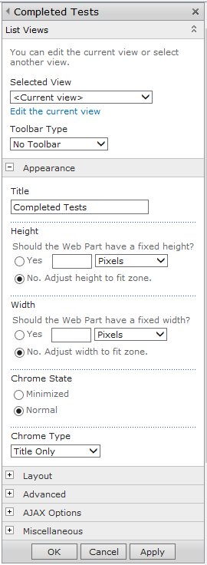

Change Toolbar Type to No Toolbar

Set Title to Completed Tests

Set Chrome type to Title Only.

Under Selected View select Completed Tests

Click Apply.

Click edit the current view.

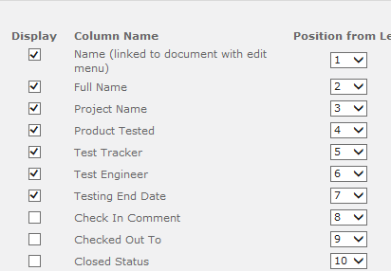

Make sure the columns match above.

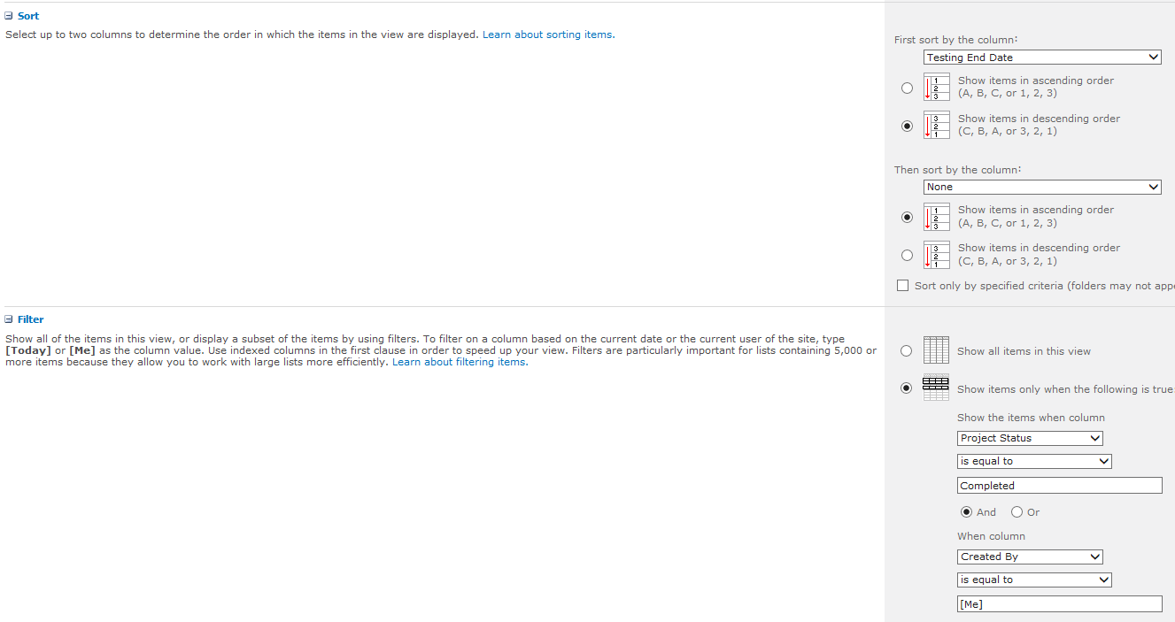

For Sort set by Testing End Date.

Set Filter to:

Project Status is equal to Completed and

Created By is equal to [Me]



Set style to Shaded.

Click OK to save.

For the left Web Part, select edit Web Part.

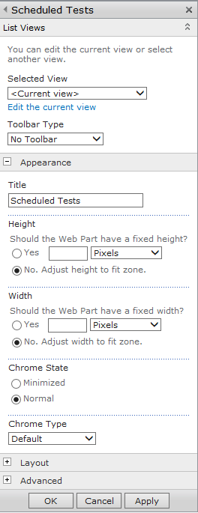

For Selected View set it to Test Calendar.

Toolbar Type is No Toolbar.

Title is Scheduled Tests

Chrome Type is Default

Click Apply. Then click on Edit the current view.

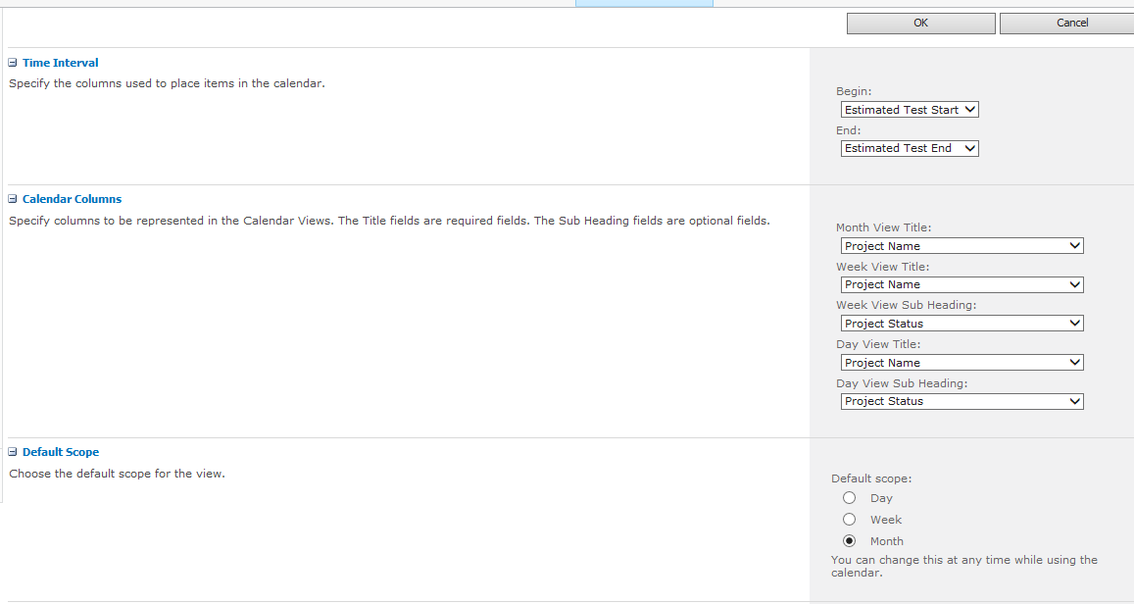

Match the settings to the above.

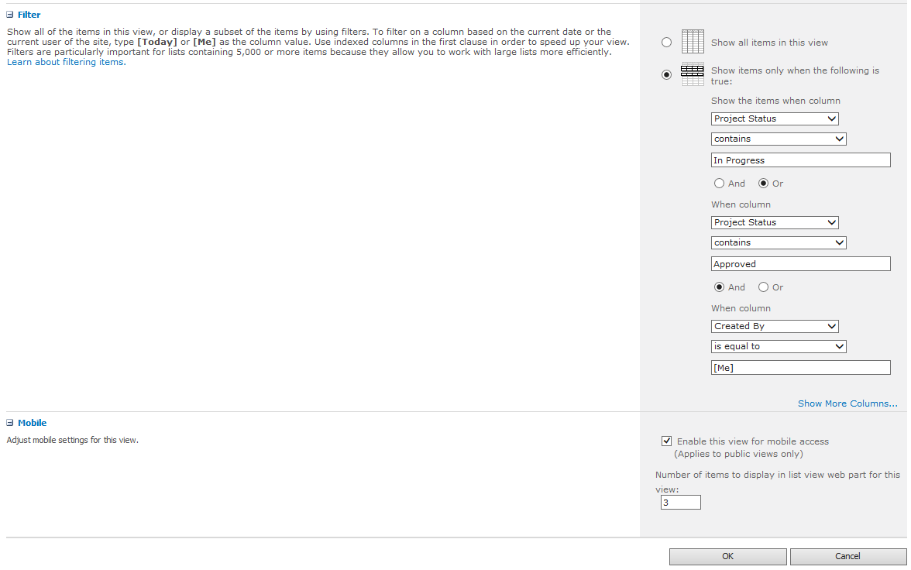

Match the settings above and hit OK to save.

Adding the New Request button.

Click Add a Web Part in the left Web Part.

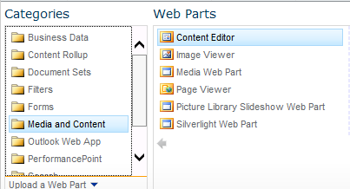

Select from the Media and Content Category. Then Select the Content Editor and hit the Add button.

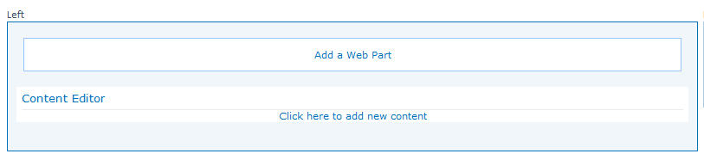

Click Click here to add new content.

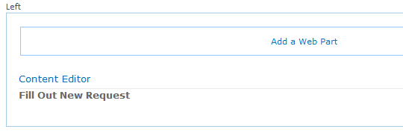

Type in Fill Out New Request. Highlight the text and in the upper toolbar select Bold and 10pt for the type.

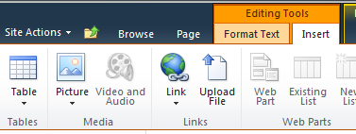

On the Insert tab of the Editing Tools, select the Picture Icon and select Image from computer (if that is the image location).

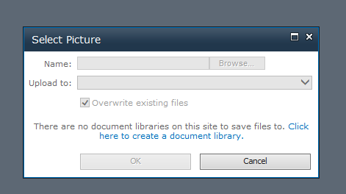

If you get this message, select Click here to create a document library.

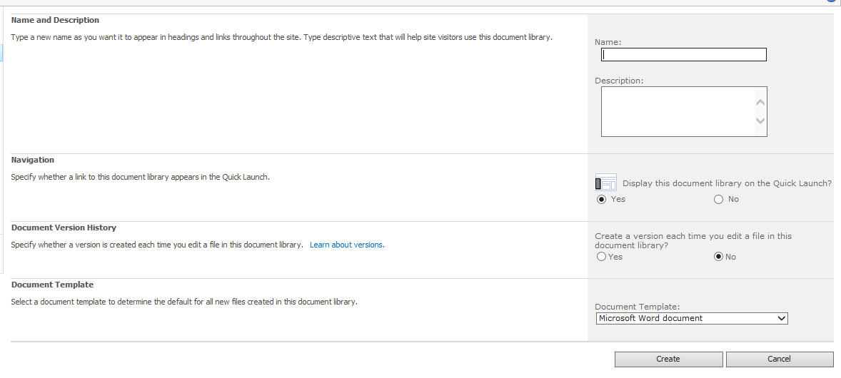

For Name type in Tester Doc Library click Create.

Go Back to the Homepage and select Edit Page.

Click Click here to add new content.



Type in Fill Out New Request. Highlight the text and in the upper toolbar select Bold and 10pt for the type.



On the Insert tab of the Editing Tools, select the Picture Icon and select Image from computer (if that is the image location).

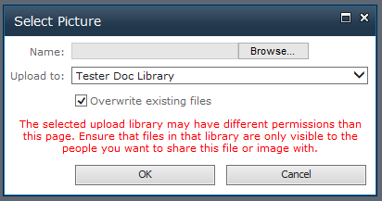

Click Browse to browse to your folder the picture is in. Once selected it will save it in the specified document library.

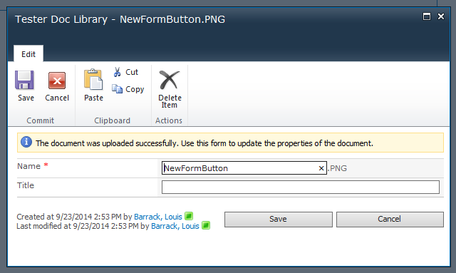

Click Save.

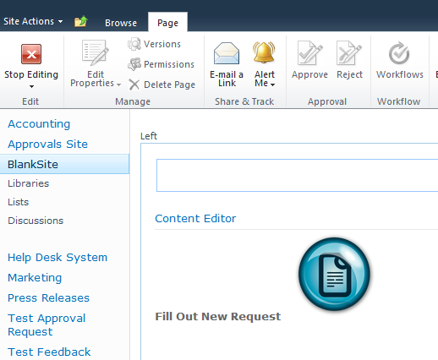

Click Stop Editing.

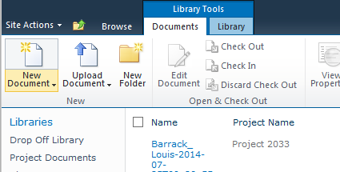

Go to the Tester Request Library and from the top ribbon, select New Document.



Copy the URL in the address bar in the browser.

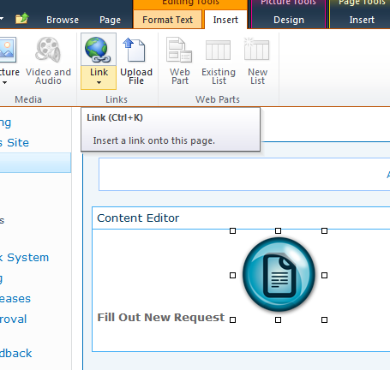

Go back to the site homepage and select Page, Edit Page.

Click on the button icon.

Click on the Link icon. Select From Address.

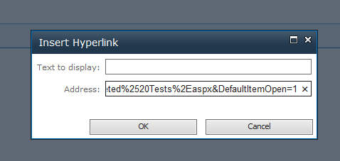

Paste the URL address you copied into the Address box and hit OK to save.

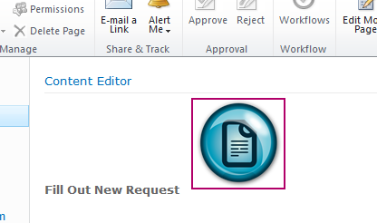

This is how it looks but there is a border around the button.

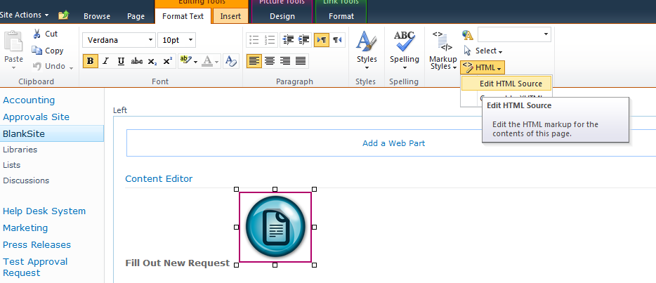

Still in Page Edit mode, click on the New Form button and on the Format Text tab under HTML select Edit HTML Source.

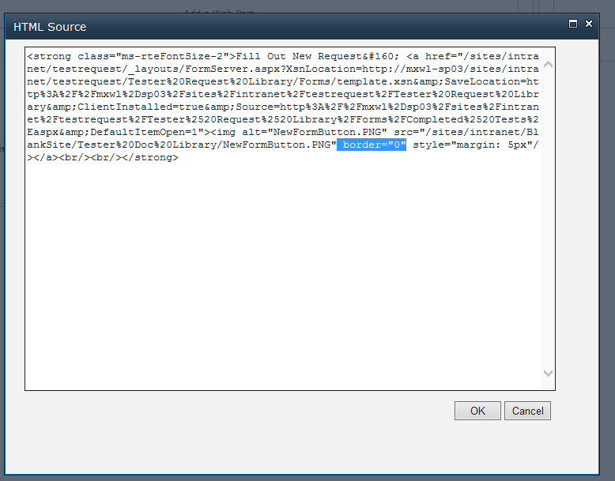

Add border=”0” like above and hit OK.

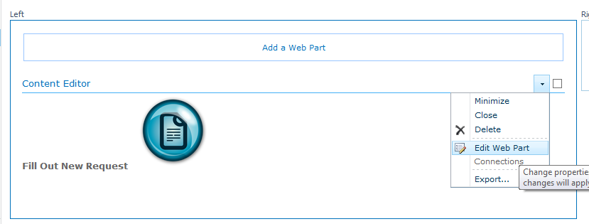

At the upper right corner select Edit Web Part.

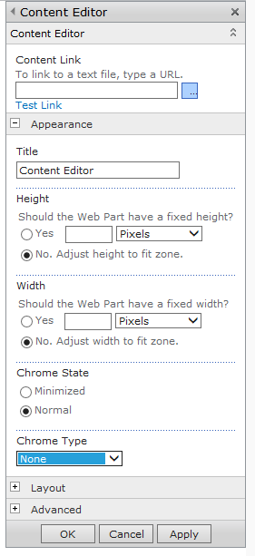

Set Chrome Type to none and hit OK to save. Click Page and Stop Editing.

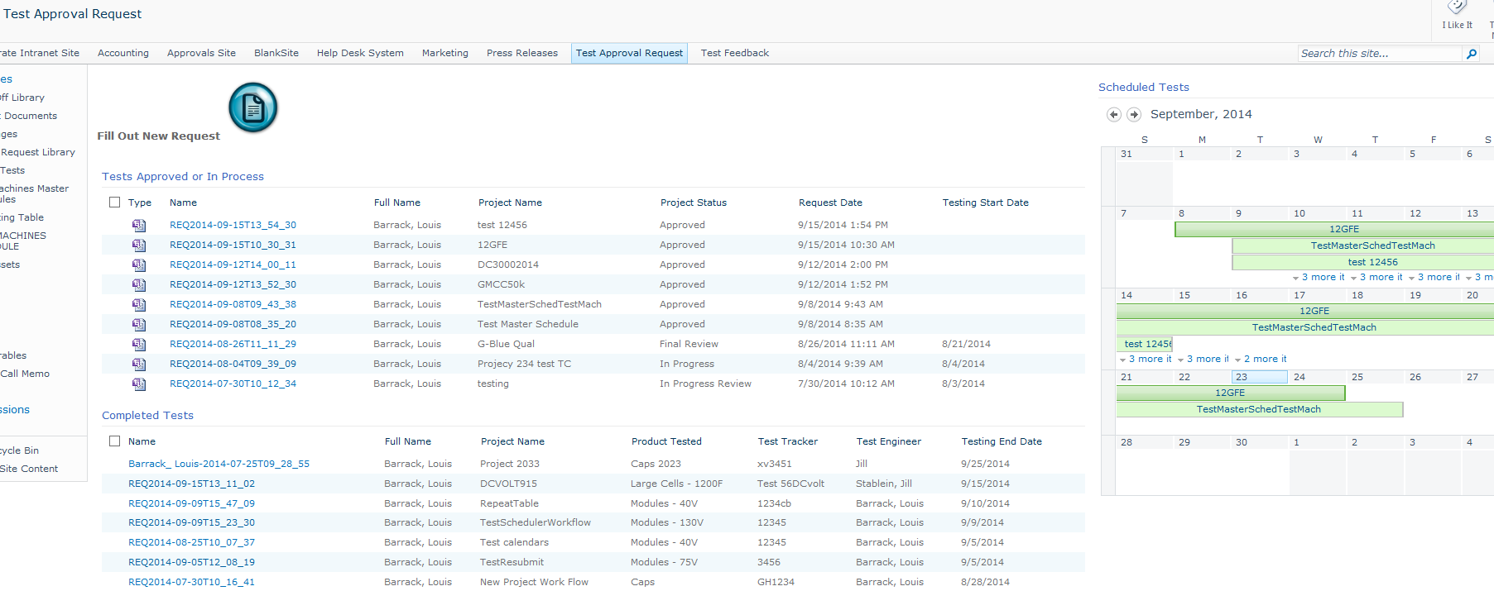

The site homepage now looks like this.